目录

Contact 4

SWT 4

R43 5

Secure roadmap 5

Test command 6

signal 7

Doc 7

AS 8

Security doc 8

Makefile 9

Log 9

主makefile 10

Security 10

CSSI分类 10

S110 11

Block diagram 11

Doc 13

Terminology 14

Lifecycle 15

MU 15

S500 15

Test Command 15

log 16

Compile 16

Boot 17

Trust management for NPU 18

Code 18

S50 19

Register 19

S50 cipher使用示例 24

Case Porting 31

EWM 31

PIN_MUX 32

VIP 32

MUX PTA3_EWM0_IN 34

tb_padi_padring 36

Tb_padi_mux3 46

VIP 51

Tb_pad_if 57

Tb_padi_if 58

Register 60

CTRL 60

COMPARE LOW 61

COMPARE HIGH 61

CLKPRESCALER 62

Function 63

Ewm_out_b 63

SWT 64

Contact 64

RTL 65

RESET VALUE 65

SWT_CR 65

S110 66

MU 66

宏定义 66

# Contact

SE Secure architecture: Nipun Mahajan <[nipun.mahajan@nxp.com](mailto:nipun.mahajan@nxp.com)>

**Change to : Miroslav Knezevic**

IP owner： Filippo Cioni [filippo.cioni@nxp.com](mailto:filippo.cioni@nxp.com)

S500 soc verification owner:Karan Bhardwaj [karan.bhardwaj@nxp.com](mailto:karan.bhardwaj@nxp.com)

# SWT

IP：D_IP_SWT_SYN_1.10

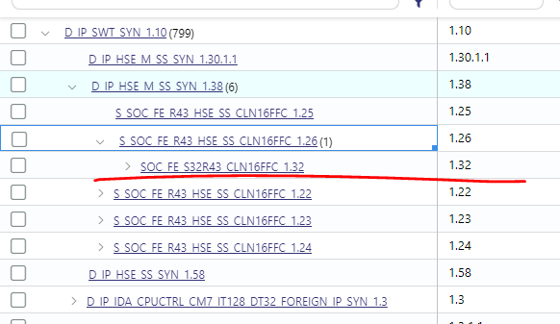

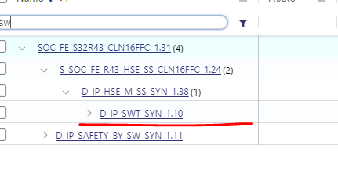

## R43

Cases can be refer to R43, below are the path:

/sync/publish/_ip/fc/fc9ca7668910dd7c030c2dd4d10d0302/v_ss_platstim_vip/vplan/ SWT0.csv

SWT function:

/sync/publish/_ip/fc/fc9ca7668910dd7c030c2dd4d10d0302/v_ss_platstim_vip/tool_data/compiler/include

SWT stimulus

/sync/publish/_ip/fc/fc9ca7668910dd7c030c2dd4d10d0302/v_ss_platstim_vip/vectors/swt_unified/stimulus

/home/r43_verif/users/michael/testbench/blocks/soc_tb/tool_data/compiler/include

# Secure roadmap

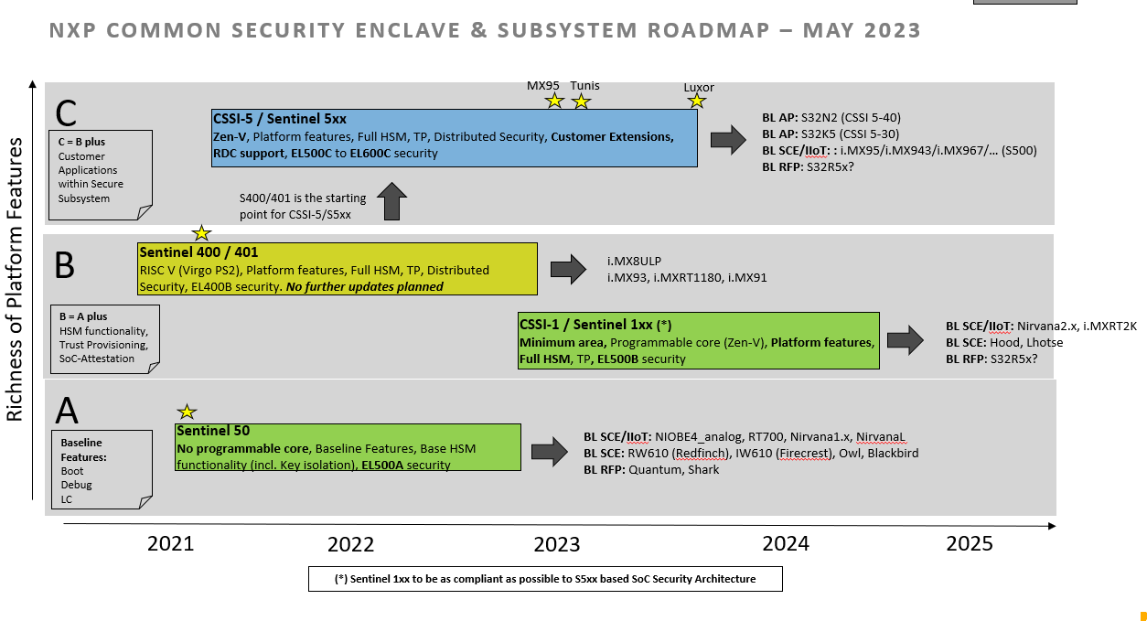

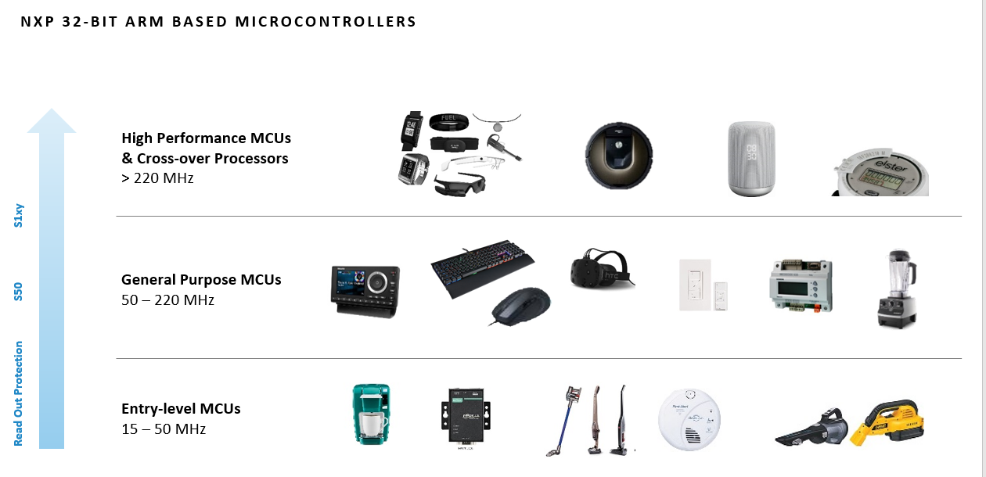

# Test commands

For cssi sanity

bsub -R rhel7 -q interq -Ip soc verilog -irun -block soc_tb -bc rtl -collect_arg -tc default -vectors sanity -test_name simple__cssi -64bit -sim_arg " +MEMDUMP +DELTACYCLE -gui " -keeptemps -shm -session default&

sanity with CM85

bsub -q interq -Ip soc verilog -irun -block soc_tb -bc rtl -collect_arg -tc default -vectors sanity -test_name simple -64bit -sim_arg " +MEMDUMP +DELTACYCLE -gui " -keeptemps -shm -session default&

bsub -q interq -Ip soc verilog -irun -block soc_tb -bc rtl -collect_arg -tc default -vectors sanity -test_name simple -64bit -sim_arg " +DELTACYCLE " -shm -session default&

开波形

进入shm文件夹，打开后缀-30以内的所有波形

bsub simvision -64bit *-[0-9].trn *-[0-3][0-9].trn &

EWM:

bsub -q batchq -n 3 soc verilog -irun -block soc_tb -bc rtl -collect_arg -tc default -vectors ewm -test_name ewm_assin__inst0__pin_opt0 -64bit -sim_arg " +DUMP_START=800000 +MEMDUMP +DELTACYCLE -gui " -proj_lib -keeptemps -comp_arg " +access+rwc +sv -linedebug " -shm -session ewm-assign &

bsub -q interq -Ip soc verilog -irun -block soc_tb -bc rtl -collect_arg -tc default -vectors ewm -test_name ewm_reg__inst0 -64bit -sim_arg " +MEMDUMP +DELTACYCLE -gui " -proj_lib -keeptemps -comp_arg " +access+rwc +sv -linedebug " -shm -session default&

bsub -q interq -Ip soc verilog -irun -block soc_tb -bc rtl -collect_arg -tc default -vectors ewm -test_name ewm_int__inst0 -64bit -proj_lib -keeptemps -comp_arg " +access+rwc +sv -linedebug " -shm -session ewm-int&

bsub -q interq -Ip soc verilog -irun -block soc_tb -bc rtl -collect_arg -tc default -vectors ewm -test_name ewm_out__inst0__pin_opt0 -64bit -sim_arg " +MEMDUMP +DELTACYCLE -gui " -proj_lib -keeptemps -comp_arg " +access+rwc +sv -linedebug " -shm -session ewm-out&

SWT:

bsub -q interq -Ip soc verilog -irun -block soc_tb -bc rtl -collect_arg -tc default -vectors swt -test_name swt_reg__inst0 -64bit -sim_arg " +DUMP_START=1700000 +MEMDUMP +DELTACYCLE -gui " -proj_lib -keeptemps -comp_arg " +access+rwc +sv -linedebug " -shm -session swt&

bsub -q interq -Ip soc verilog -irun -block soc_tb -bc rtl -collect_arg -tc default -vectors swt -test_name swt_interrupt__inst0 -64bit -sim_arg " +MEMDUMP +DELTACYCLE -gui " -proj_lib -keeptemps -comp_arg " +access+rwc +sv -linedebug " -shm -session swt-int&

CSSI

bjobs

batchq:

bsub -q batchq -n 3 soc verilog -irun -block soc_tb -bc rtl -collect_arg -tc default -vectors s110 -test_name cssi_reg_mu0__cm85__cssi_reg_mu__inst0__cssi__cssi_reg_mu__inst0 -64bit -sim_arg " +MEMDUMP +DELTACYCLE -gui " -proj_lib -keeptemps -shm -session cssi-porting-mu &

bsub -q interq -Ip soc verilog -irun -block soc_tb -bc rtl -collect_arg -tc default -vectors s110_mu -test_name cssi_reg_mu0__cm85__cssi_reg_mu__inst0__cssi__cssi_reg_mu__inst0 -64bit -sim_arg " +MEMDUMP +DELTACYCLE -gui " -proj_lib -keeptemps -shm -session cssi-porting-mu &

bsub -q interq -Ip soc verilog -irun -block soc_tb -bc rtl -collect_arg -tc default -vectors s110 -test_name s110_pkc_retention_eien__cm85__s110_pkc_retention__pdown__inst0__cssi__s110_pkc_retention__pdown__inst0 -64bit -sim_arg " +DUMP_START=800000 +MEMDUMP +DELTACYCLE -gui " -proj_lib -keeptemps -shm -session cssi-pkc_retention-2

bsub -q interq -Ip soc verilog -irun -block soc_tb -bc rtl -collect_arg -tc default -vectors s110 -test_name s110_pkc_retention__cm85__s110_pkc_retention__pdown__inst0__cssi__s110_pkc_retention__pdown__inst0 -64bit -sim_arg " +DUMP_START=800000 +MEMDUMP +DELTACYCLE -gui " -proj_lib -keeptemps -shm -session cssi-pkc_retention

## performance:

bsub -q interq -Ip soc verilog -irun -block soc_tb -bc rtl -collect_arg -tc default -vectors s110_mu -test_name cssi_reg_mu0__cm85__cssi_reg_mu__inst0__cssi__cssi_reg_mu__inst0 -64bit -sim_arg " +MEMDUMP +DELTACYCLE -gui " -proj_lib -keeptemps -shm -session cssi-porting-mu &

bsub -q interq -Ip soc verilog -irun -block soc_tb -bc rtl -collect_arg -tc xspi -vectors s110 -test_name s110_access_xspi_flash_sha_gcm_32Byte__cm85__s110_access_xspi_flash_sha_gcm_32Byte__inst0__pin_opt0__cssi__s110_access_xspi_flash_sha_gcm_32Byte__inst0__pin_opt0 -64bit -sim_arg " +MEMDUMP +DELTACYCLE -gui " -proj_lib -keeptemps -shm -session cssi-performance-xspi &

bsub -q interq -Ip soc verilog -irun -block soc_tb -bc rtl -collect_arg -tc default -vectors s110_mu -test_name cssi_attr_secure_priviledge_access_mu0__cm85__cssi_attr_mu__inst0__cssi__cssi_attr_mu.cssi__inst0 -64bit -keeptemps -shm -session cssi-porting &

bsub -q interq -Ip soc verilog -irun -block soc_tb -bc rtl -collect_arg -tc default -vectors S500_MISC -test_name s400_all_ips__cm33__s400_all_ips__inst0__core_s3__s400_all_ips.s400__inst0 -64bit -keeptemps -shm -session cssi-porting &

bsub -q interq -Ip soc verilog -irun -block soc_tb -bc rtl -collect_arg -tc default -vectors sanity -test_name simple__cssi -64bit -keeptemps -shm -session default &

## UPF

bsub -q interq -I soc vcsmx -block soc_tb -bc vcs_upf -collect_arg -tc default -vectors s110 -test_name s110_pkc_retention_eien__cm85__s110_pkc_retention__pdown__inst0__cssi__s110_pkc_retention__pdown__inst0 -proj_lib -fsdb -session -pkc_retention_upf &

## ROM command

bsub -o log_reset.txt -q xlongq soc verilog -xrun -block soc_tb -bc rtl -collect_arg -tc xspi -64bit -proj_lib -no_compile -shm -session default -comp_arg "+access+rwc +sv +define+ZV2355_TARMAC_ENABLE" -sim_arg "+trace_inst=2 +NO_LOOP_TCM_INITIAL_DONE +ENABLE_LFRO32K_SPEEDUP" -make_arg "CM85_INST_MEM=boot_vector CM85_DATA_MEM=sram0 CM85_STACK_MEM=sram0 " -keeptemps -vectors pkc_wf -test_name RTL_RT2660_A0_S40xReset-FAB-0

CSSI_1.9 super block

bsub -q interq -I soc verilog -xrun -block soc_tb -bc superblock -collect_arg -tc cssi -vectors sanity -test_name simple__cssi -64bit -sim_arg " +MEMDUMP +DELTACYCLE -gui " -proj_lib -keeptemps -comp_arg "+access+rwc +sv -linedebug -pkgsearchdefault -enable_work_yvlib" -shm -configflow -session cssi &

test_mu__cm85__test_cssi_mu__inst0__cssi__test_cssi_mu.cssi__inst0.arg

bsub -q interq -I soc verilog -xrun -block soc_tb -bc superblock -collect_arg -tc cssi -vectors s110_mu -test_name cssi_reg_mu0__cm85__cssi_reg_mu__inst0__cssi__cssi_reg_mu.cssi__inst0 -64bit -sim_arg " +MEMDUMP +DELTACYCLE -gui " -proj_lib -keeptemps -comp_arg "+access+rwc +sv -linedebug -pkgsearchdefault -enable_work_yvlib" -shm -configflow -session cssi &

test：

bsub -q interq -I soc verilog -xrun -block soc_tb -bc superblock -collect_arg -tc cssi -vectors s110_mu -test_name test_mu__cm85__test_cssi_mu__inst0__cssi__test_cssi_mu.cssi__inst0 -64bit -sim_arg " +MEMDUMP +DELTACYCLE -gui " -proj_lib -keeptemps -comp_arg "+access+rwc +sv -linedebug -pkgsearchdefault -enable_work_yvlib" -shm -configflow -session cssi &

SWT

bsub -q interq -I soc verilog -xrun -block soc_tb -bc rtl -collect_arg -tc default -vectors swt -test swt_reg__inst1 -64bit -sim_arg " +MEMDUMP +DELTACYCLE -gui " -proj_lib -keeptemps -comp_arg " +access+rwc +sv -linedebug " -shm -session default &

s

# arg

修改design编译需要的IP

soc_arg += -bc_override "a_ip_pll_usb_480mhz_ln28fdsoi=bhv,a_ip_osc_mhz_ln28fdsoi=uc_svreal"

# signal

axbs:

testbench.top.main_ss_ft_wrap.main_ss.main_axbs_decode.sel_slv_m0

# Doc

RT2260 [sharepoint](https://nxp1.sharepoint.com/teams/210_34/Documents/Forms/AllItems.aspx?FolderCTID=0x0120008AAC303450669742B41A366E5B000C6E&viewid=02d95bb5%2D63ac%2D4321%2D8357%2D08f78e170813)

[Timesheet](https://nxp1.sharepoint.com/:x:/r/sites/SuzhouSoCverification/_layouts/15/Doc.aspx?sourcedoc=%7B938A6937-462E-4E97-A26A-B5D1838DB6EE%7D&file=2024_project_plan_suzhou_verification_April_9_2024.xlsx&wdLOR=c8B2E02DF-D091-40FB-8406-C1F3E3B8FFD3&action=default&mobileredirect=true)

IP Reuse：[​xlsx icon RT2660 IP Re-USE v0.1.xlsx](https://nxp1.sharepoint.com/:x:/r/teams/210_34/Documents/04_Design/IP%20Reuse%20Table/RT2660%20IP%20Re-USE%20v0.1.xlsx?d=wba626b09c72f49aebbe5ff2a96ef4bcd&csf=1&web=1&e=onXi7G),



## AS

[​pdf icon 20240212-RT2660_HW_AS 0v3_review.pdf](https://nxp1.sharepoint.com/:b:/r/teams/210_34/Documents/05_Systems/Architecture%20Spec/20240212-RT2660_HW_AS%200v3_review.pdf?csf=1&web=1&e=yhj1kO)

## Security doc

training： [Security Awareness Training Advanced](https://nww.sharepoint.nxp.com/teams/97/SitePages/Security%20Awareness%20Training.aspx)

ELM: [Link](https://elm.nxp.com/rm/web#action=com.ibm.rdm.web.pages.showArtifactPage&artifactURI=https%3A%2F%2Felm.nxp.com%2Frm%2Freviews%2F_mdJrAeVcEe67J74haR_uXA&componentURI=https%3A%2F%2Felm.nxp.com%2Frm%2Frm-projects%2F_YVnvEJuvEe6SD7AeCwYG7Q%2Fcomponents%2F_YaGmcJuvEe6SD7AeCwYG7Q&vvc.configuration=https%3A%2F%2Felm.nxp.com%2Frm%2Fcm%2Fbaseline%2F_PmTm0OTzEe67J74haR_uXA) CSSI AS was in ELM system

Seclore: [Link](https://nxp.stringsend.com/nxp/) IMX943 RM was in Seclore

Soc IG guide： [CSSI soc support doc](https://nww.amec.sharepoint.nxp.com/teams/248_3/CSSI/Forms/AllItems.aspx?FolderCTID=0x01200025BEBFE641975E49B4D1230D3AB3F49A&id=%2Fteams%2F248%5F3%2FCSSI%2FDocs%2FSoC%20Support%20Docs%2FCSSI)

RM： [CSSI_Seclore_doc](https://nww.amec.sharepoint.nxp.com/teams/248_3/Seclore%20Docs/Forms/AllItems.aspx?RootFolder=%2fteams%2f248%5f3%2fSeclore%20Docs%2fCSSI&FolderCTID=0x01200001937A3F47FFF44F977204EE7B8D2C4A) （需要安装seclore）

Install Seclore app in windows:

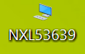

1. Request app in software center [link](https://nxp2.service-now.com/sp?id=sc_cat_item&table=sc_cat_item&sys_id=e940565487040a98000adcaabbbb353a&recordUrl=com.glideapp.servicecatalog_cat_item_view.do%3Fv%3D1&sysparm_id=e940565487040a98000adcaabbbb353a), fill the device name
2. Once request approved, install Seclore

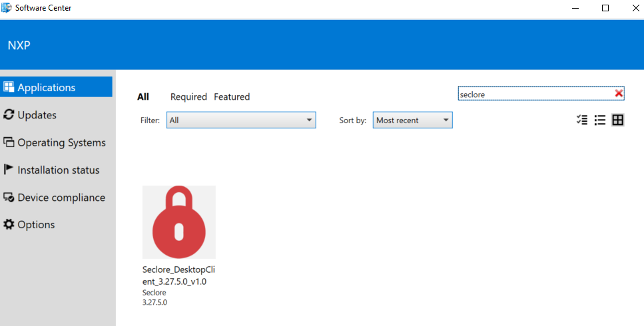

# Makefile

Imx95：

Log：

/home/imx95_verif_nobackup/usr/nxa28190/imx95_b0/vcsmx_rtl_unit_default/cssi_boot/_SOC/s400_single_boot_flow__cm33__s400_single_boot_flow__inst0__core_s3__s400_single_boot_flow.s400__inst0

Waveform:

/home/imx95_verif_nobackup/usr/nxa28190/imx95_b0/vcsmx_rtl_unit_default/cssi_boot/s400_single_boot_flow__cm33__s400_single_boot_flow__inst0__core_s3__s400_single_boot_flow.s400__inst0VrtlCunitM.fsdb

## Log

# | /home/imx95_verif/usr/nxa28190/imx95_b0/testbench/blocks/soc_tb/tool_data/compiler/include/c_mem_map.h

# | /home/imx95_verif_nobackup/usr/nxa28190/imx95_b0/vcsmx_rtl_unit_default/default.linux26_64bit/mem_map.v

### Target CPU : cm33_s

### Target CPU Type : cm33

### Target CPU : zenv

### Target CPU Type : zenv

/home/imx95_verif/usr/nxa28190/imx95_b0/testbench/common_blocks/v_ip_makefile_zenv/tool_data/compiler/makefile.stimulus.compile

## 主makefile

/home/imx95_verif/usr/nxa28190/imx95_b0/testbench/blocks/soc_tb/testbench/makefile.stimulus

# Security

S110 = CSSI_1_10

Common Security SubSystem IP (CSSI)

S50- CSS = Crypto Secure Sequencer

## CSSI分类

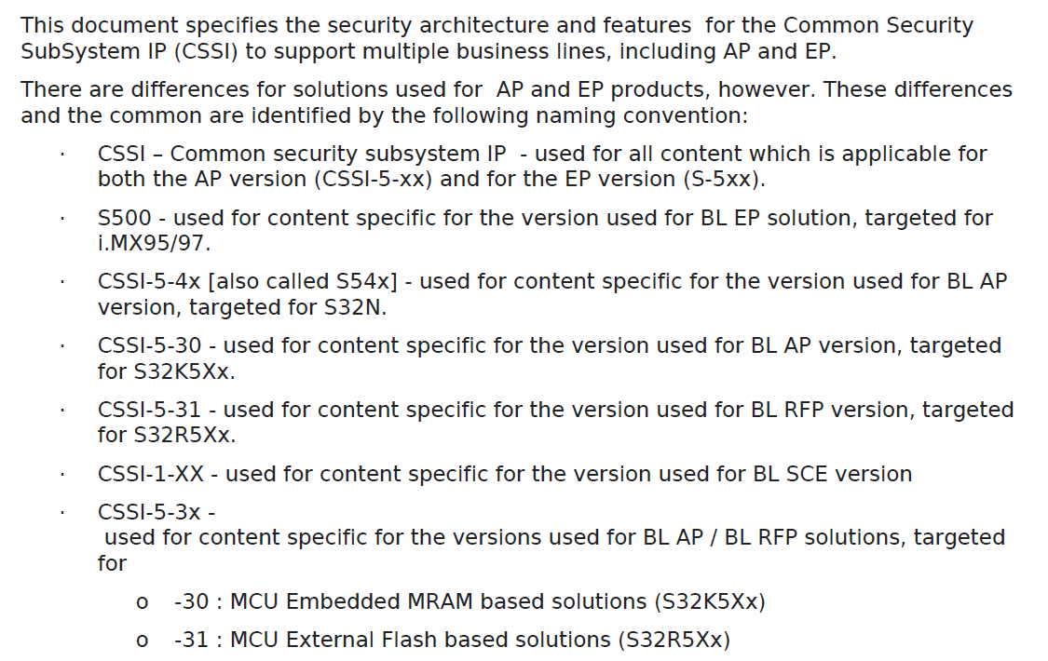

## S110

### Block diagram

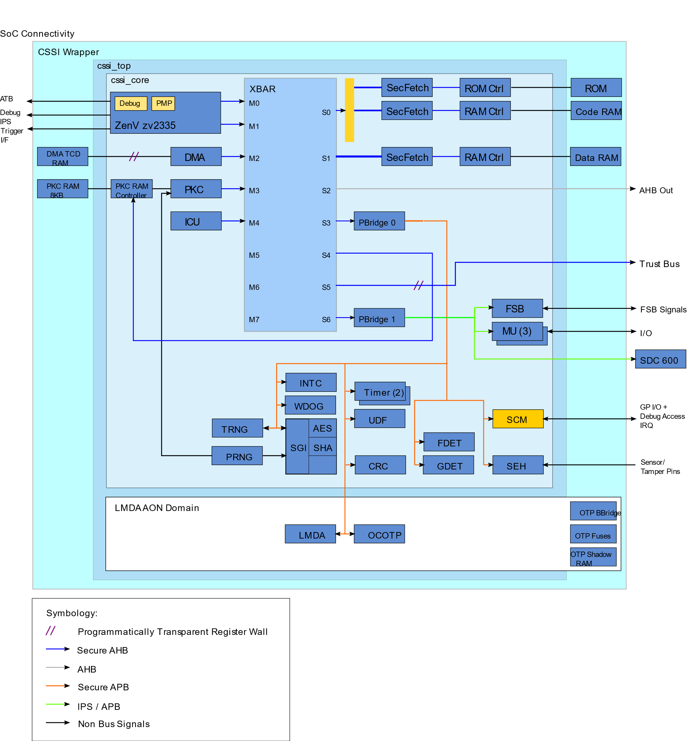

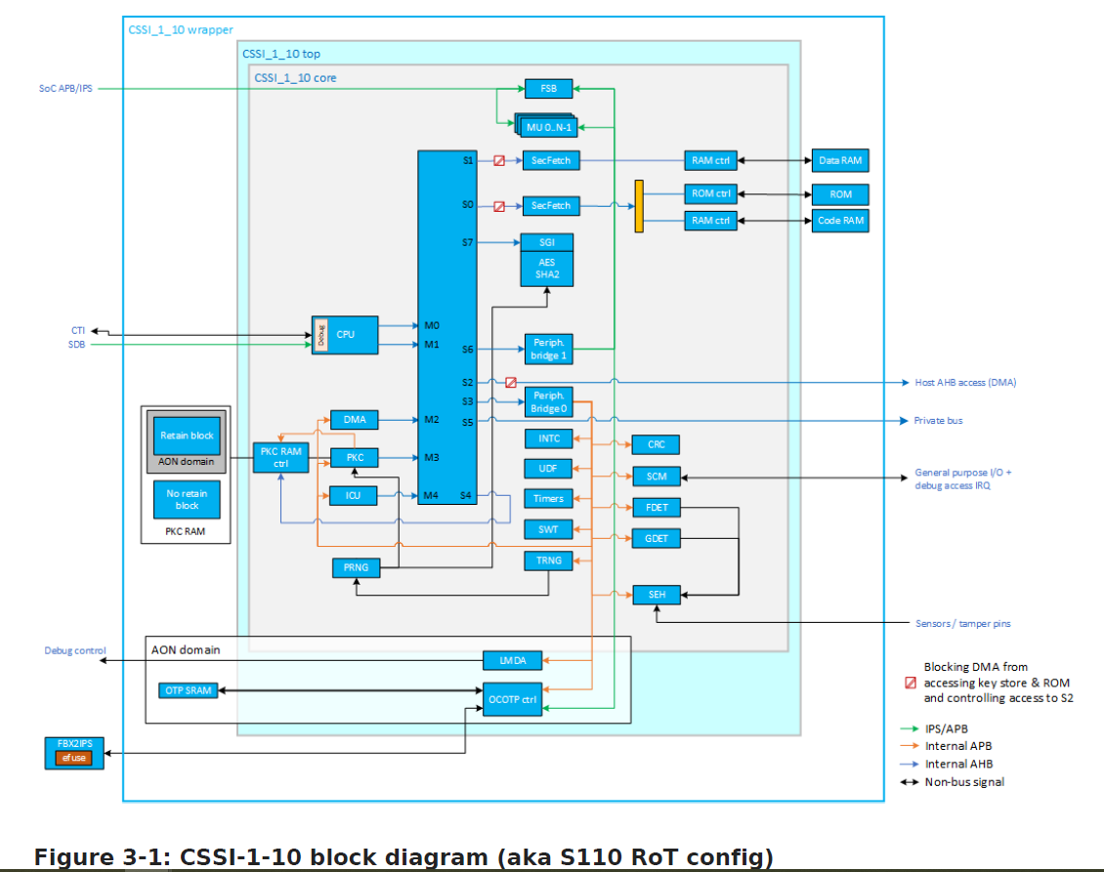

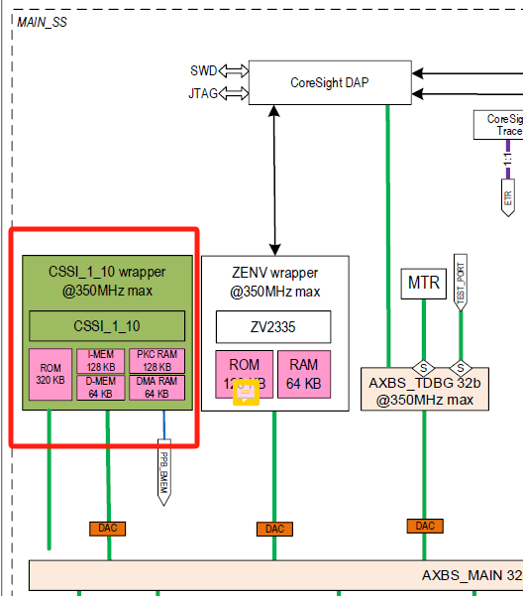

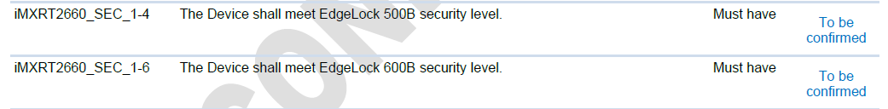

#### SOC connection

S110 was resident in main SS

S110 access SOC resources by AHB M4 port.

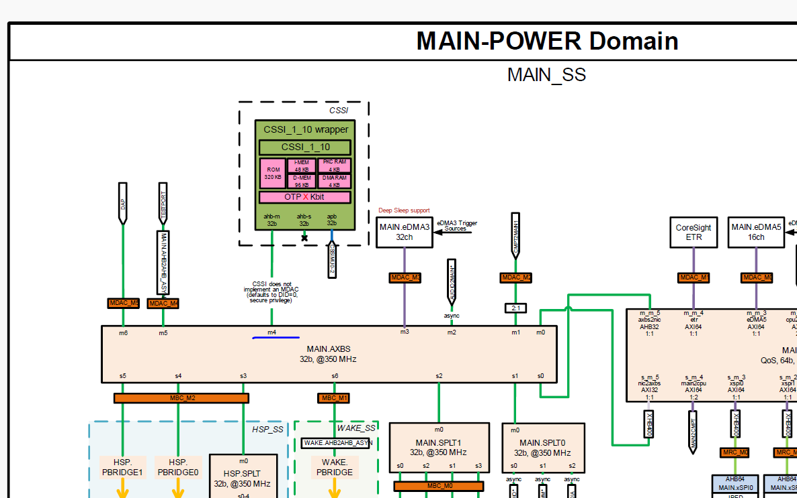

### Doc

[CSSI](https://nww.amec.sharepoint.nxp.com/teams/248_3/CSSI/Forms/AllItems.aspx?RootFolder=%2fteams%2f248%5f3%2fCSSI%2fDocs%2fSoC%20Support%20Docs&FolderCTID=0x01200025BEBFE641975E49B4D1230D3AB3F49A) User guide/Integration guide

* Specs:

[Common Security Subsystem IP (CSSI) AS part 1](https://elm.nxp.com/rm/resources/MD_90ZMYJ3NEe6SD7AeCwYG7Q?vvc.configuration=https%3A%2F%2Felm.nxp.com%2Frm%2Fcm%2Fbaseline%2F_PmTm0OTzEe67J74haR_uXA)  
[Common Security Subsystem IP (CSSI) AS part 2](https://elm.nxp.com/rm/resources/MD_ClIXgJ3OEe6SD7AeCwYG7Q?vvc.configuration=https%3A%2F%2Felm.nxp.com%2Frm%2Fcm%2Fbaseline%2F_PmTm0OTzEe67J74haR_uXA)  
[Common Security Subsystem IP (CSSI) RS](https://elm.nxp.com/rm/resources/MD_vHvf0J3PEe6SD7AeCwYG7Q?vvc.configuration=https%3A%2F%2Felm.nxp.com%2Frm%2Fcm%2Fbaseline%2F_PmTm0OTzEe67J74haR_uXA)

* Access the Review: [RT2660 S110 HW AS review](https://elm.nxp.com/rm/reviews/_mdJrAeVcEe67J74haR_uXA)

### Terminology

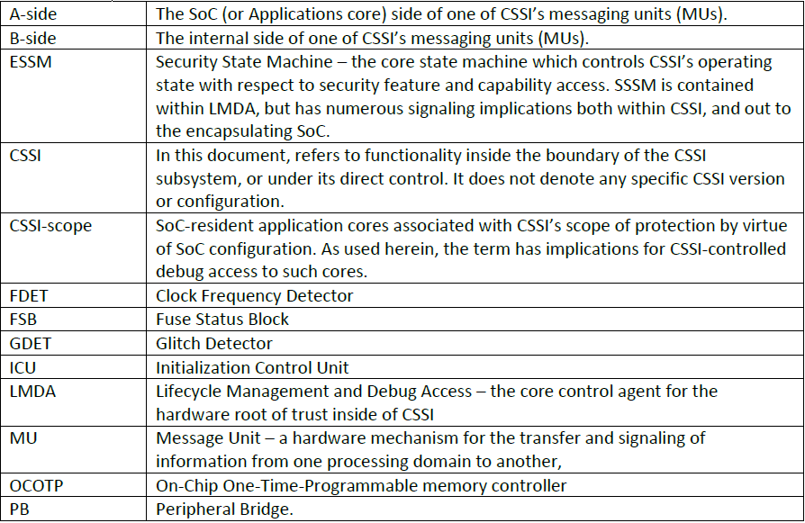

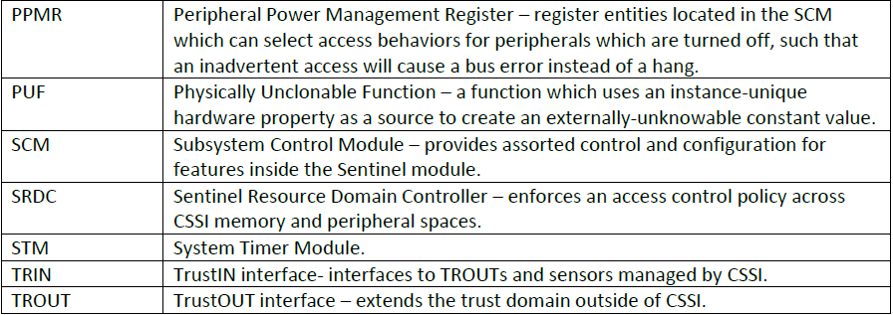

### Memory map

|  |  |  |  |
| --- | --- | --- | --- |
| Start Address | End Address | Port | Slave Description |
| 0x0000_0000 | 0xdfff_ffff | S2 | External output to SoC |
| 0xe000_0000 | 0xe004_ffff | S0 | ROM 320K-bytes |
| 0xe7fe_0000 | 0xe7ff_ffff | S0 | IMEM 96Keg-bytes |
| 0xe800_0000 | 0xe800_bfff | S1 | DMEM 48K-bytes |
| 0xeb00_0000 | 0xeb00_1fff | S4 | DMEM PKC (PKC) 8K-bytes |
| 0xec00_0000 | 0xec05_ffff | S3 | Internal Peripherals ** |
| 0xed00_0000 | 0xed03_ffff | S6 | SoC-interconnected Peripherals ** |
| 0xee00_0000 | 0xefff_ffff | S5 | TrustBus |
| 0xf000_0000 | 0xffff_ffff |  | Reserved |

### Lifecycle

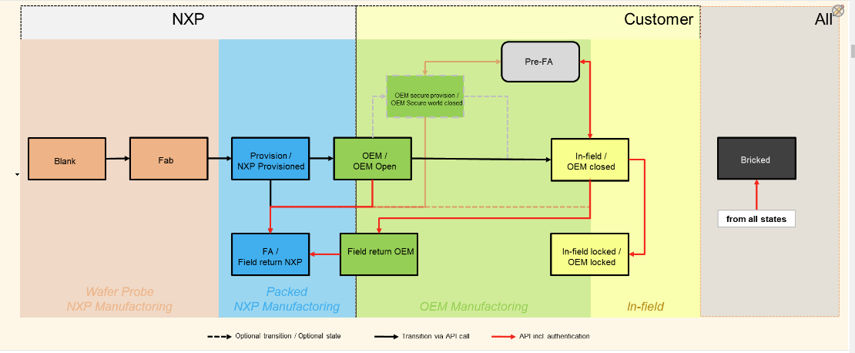

### MU

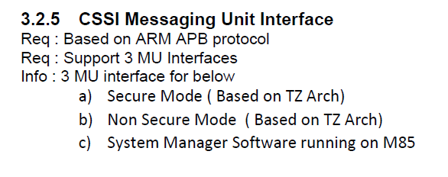

## S500

### Test Command

进入如下目录/home/mx943_verif/usr/richard_nxa28190/1.45/testbench/blocks/soc_tb/testbench

make vcsmx_rtl_comp IMX95=yes vcsmx_rtl_sim vectors=cssi_boot tc=default testname=s400_single_boot_flow__cm33__s400_single_boot_flow__inst0__core_s3__s400_single_boot_flow.s400__inst0 args=-sim_arg\ +dontStopOnSimulError=1

imx943:

bsub -R rhel7 -q interq -Ip make vcsmx_rtl_sentinel_comp vcsmx_rtl_sentinel_sim vectors=s500_mu testname=s400_reg_mu0__cm33__s400_reg_mu__inst0__core_s3__s400_reg_mu.s400__inst0 XPROP=0 args=-sim_arg\ +dontStopOnSimulError=1 &

Verdi -ssf

### log

/home/imx95_verif_nobackup/usr/nxa28190/imx95_b0/vcsmx_rtl_unit_sentinel/cssi_boot/vcsmx_FILENAMES_apcw401i-10-60-37-117.nxdi.kr-awsc1.nxp.com_65464/makefile.tbc

INFO: Creating file

/home/imx95_verif_nobackup/usr/nxa28190/imx95_b0/vcsmx_rtl_unit_sentinel/cssi_boot/vcsmx_FILENAMES_apcw401i-10-60-37-117.nxdi.kr-awsc1.nxp.com_65464/runsim.sh

INFO: Creating file

/home/imx95_verif_nobackup/usr/nxa28190/imx95_b0/vcsmx_rtl_unit_sentinel/cssi_boot/vcsmx_FILENAMES_apcw401i-10-60-37-117.nxdi.kr-awsc1.nxp.com_65464/runall.sh

/home/imx95_verif_nobackup/usr/nxa28190/imx95_b0/vcsmx_rtl_unit_sentinel/cssi_boot/_SOC/s400_single_boot_flow__cm33__s400_single_boot_flow__inst0__core_s3__s400_single_boot_flow.s400__inst0/soc_vcsmx_s400_single_boot_flow__cm33__s400_single_boot_flow__inst0__core_s3__s400_single_boot_flow.s400__inst0.log

/home/mx943_verif_nbk/usr/richard_nxa28190/1.45/vcsmx_rtl_unit_sentinel/s500_mu/logfiles

/home/mx943_verif_nbk/usr/richard_nxa28190/1.45/vcsmx_rtl_unit_sentinel/s500_mu/results/s400_reg_mu0__cm33__s400_reg_mu__inst0__core_s3__s400_reg_mu.s400__inst0VrtlCunitM.fsdb

### Compile

arm-none-eabi-as

  CC            = riscv32-unknown-elf-g++  
  AS            = riscv32-unknown-elf-as  
  LD            = riscv32-unknown-elf-ld  
  NM            = riscv32-unknown-elf-nm  
  OBJDUMP       = riscv32-unknown-elf-objdump  
  OBJCOPY       = riscv32-unknown-elf-objcopy  
  CPP           = riscv32-unknown-elf-cpp

### Boot

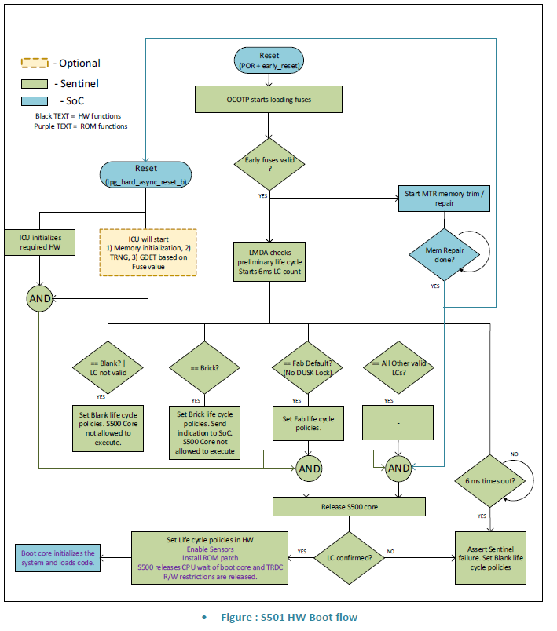

### Trust management for NPU

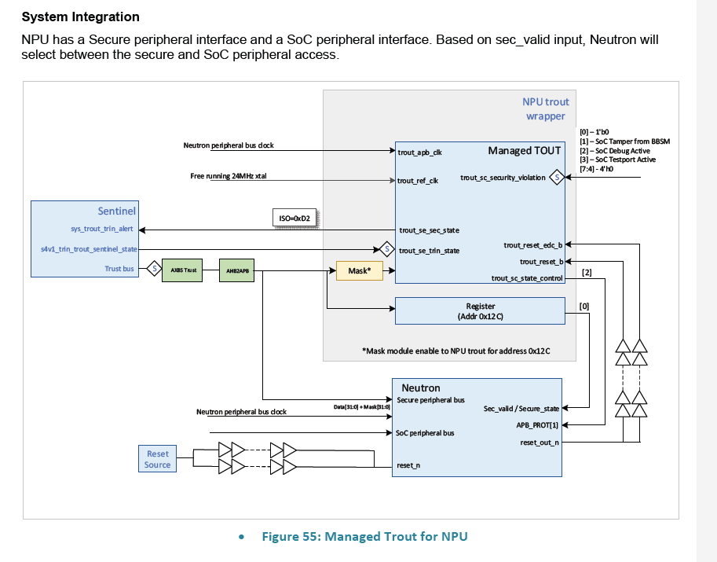

### Code

/home/imx95_verif/usr/nxa28190/imx95_b0/testbench/blocks/soc_tb/tool_data/compiler/zenv/zenv/include/pre_post_main.h

## S50

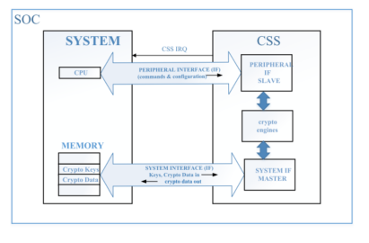

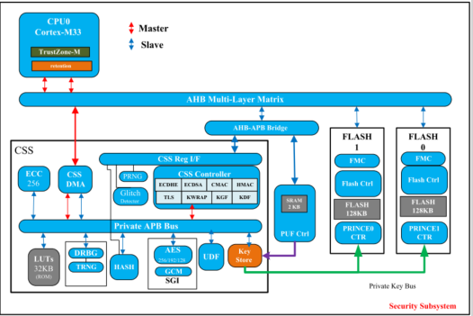

### Register

#### CSS_STATUS

Offset 0x0：

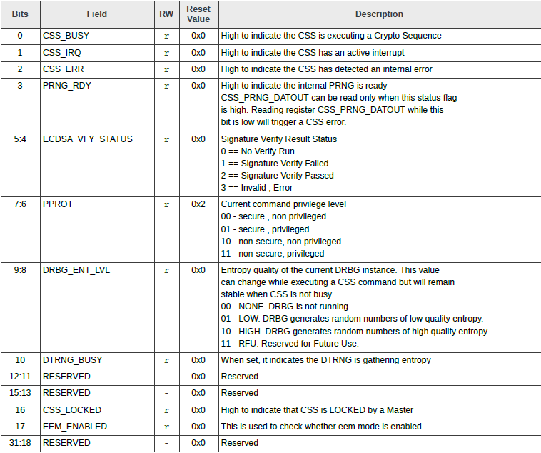

#### CSS_CTRL（enable/start）

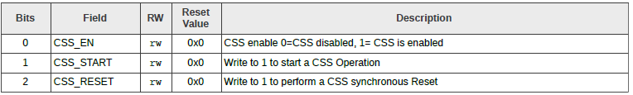

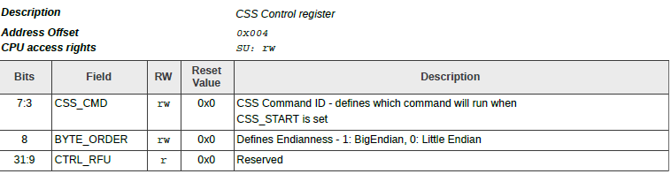

#### CSS_CMDCFG0

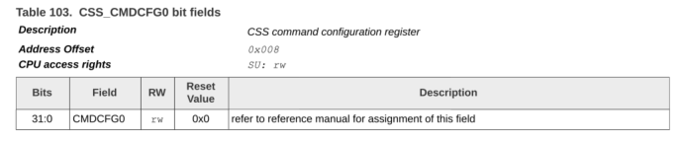

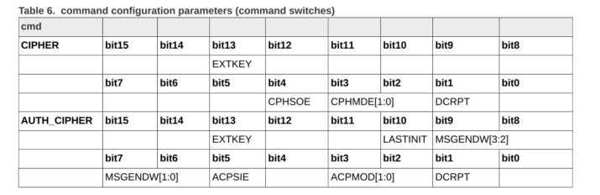

#### CSS_DMA_SRC0

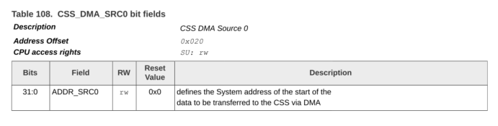

#### CSS_DMA_SCR0_LEN

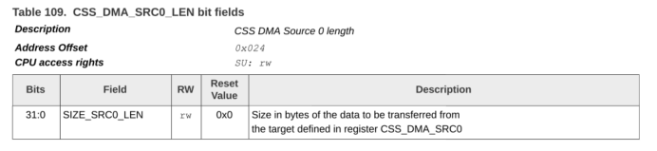

#### CSS_DMA_SRC1

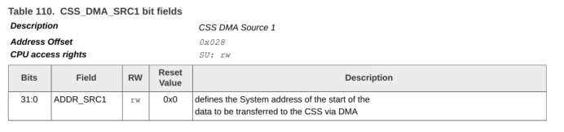

#### CSS_DMA_SRC2

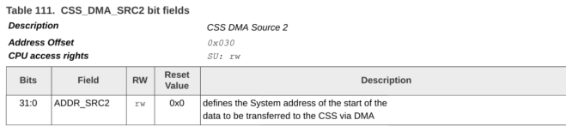

#### CSS_DMA_SRC2_LEN

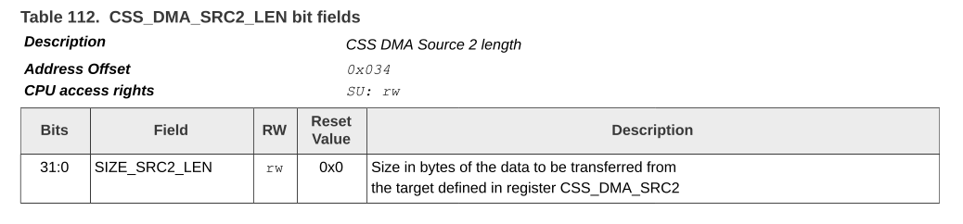

#### DMA_CSS_RES0

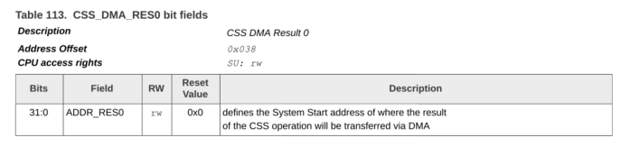

#### CSS_INT_ENABLE

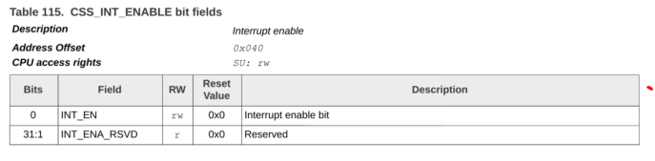

#### CSS_INT_STATUS_CLR

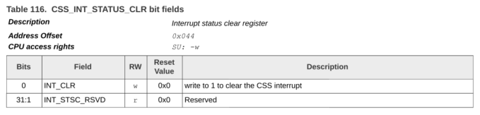

#### CSS_INT_STATUS_SET

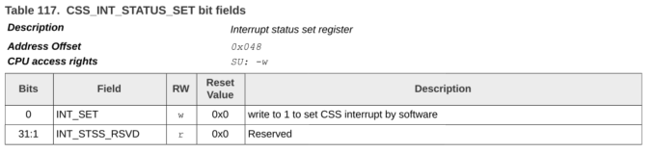

### S50 cipher使用示例

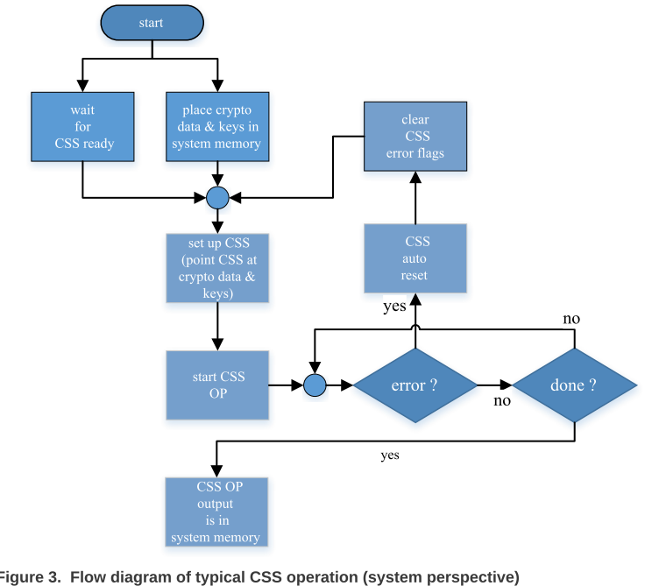

#### Enable CSS clock

// Enable CSS clock

write_syscon_cmpt_els_clk_ctrl_els_clk_en(1);

write_syscon_cmpt_els_clk_ctrl_dtrng_refclk_en(1);

W32: A=50190004 W=00000001

#### Initialize CSS

// - Write CSS_EN bit and wait for BUSY bit to go low

cssv2_init(cssv2_context);

##### enable/等待busy bit清零

W32: A=50190004 W=00000001

R32: A=50190000 R=00000482

##### 清除中断

// Clear the first interrupt //

cssv2_clear_int(cssv2_context);

W32(CSS_ERR_STATUS_CLR,BIT0);//clear inital dtrng error//according to the spec, it is not a css error

W32: A=50190044 W=00000001

##### 使能中断

// Enable cssv2 interrupt

cssv2_enable_int(cssv2_context);

BSET32: A=50190040 Ri=00000000 M=00000001 Rf=00000001

#### 系统memory中写入待加解密数据/密钥/IV

// Plaintext

for (mem_idx = 0; mem_idx < (PTX_SIZE / 4); mem_idx++) {

W32(REG32((PTX_PTR + (mem_idx << 2) + 0 + tv_idx)) , ((plaintext[tv_idx][mem_idx] >> 0 ) & 0xFF));

W32(REG32((PTX_PTR + (mem_idx << 2) + 1 + tv_idx)) , ((plaintext[tv_idx][mem_idx] >> 8 ) & 0xFF));

W32(REG32((PTX_PTR + (mem_idx << 2) + 2 + tv_idx)) , ((plaintext[tv_idx][mem_idx] >> 16) & 0xFF));

W32(REG32((PTX_PTR + (mem_idx << 2) + 3 + tv_idx)) , ((plaintext[tv_idx][mem_idx] >> 24) & 0xFF));

}

// IV

for (mem_idx = 0; mem_idx < (IV_SIZE / 4); mem_idx++) {

W32(REG32((IV_PTR + (mem_idx << 2))) , iv[tv_idx][mem_idx]);

}

// KEY

for (mem_idx = 0; mem_idx < (KEY_SIZE / 4); mem_idx++) {

W32(REG32((KEY_PTR + (mem_idx << 2))) , key[tv_idx][mem_idx]);

}

#### 配置数据到CSS DMA中

R32(CSS_STATUS,rdata);

SHOW32(STIMNAME,"CSS alias window = 0x%08x", rdata + (tv_idx << 10)); // (tv_idx << 10) is offset count in word, not in byte

##### 待加解密数据写入SRC0

// Load pointer to Plaintext

cssv2_load_dma_src0(cssv2_context, PTX_PTR + tv_idx); //TODO need +tv_idx?

cssv2_load_dma_src0_len(cssv2_context, PTX_SIZE);

W32: A=50190020 W=30000800

A=50190024 W=00000020

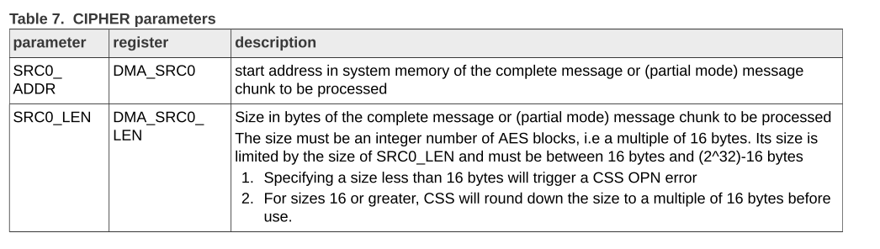

##### IV 地址写入SRC1

// Load pointer to IV (No need to write length (CSS_DMA_SRC1 works by default with 16 bytes length)

cssv2_load_dma_src1(cssv2_context, IV_PTR);

W32: A=50190028 W=30000824

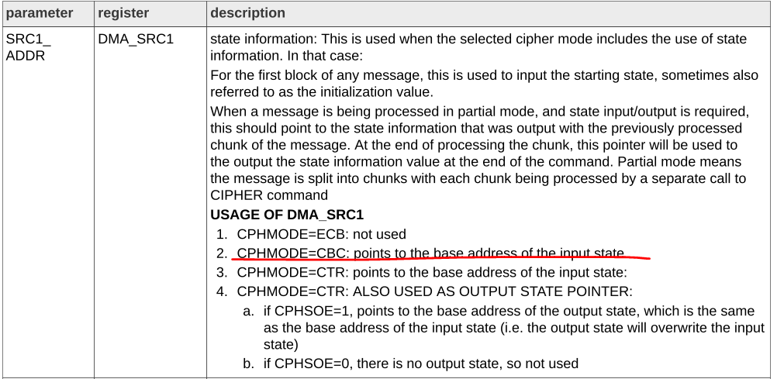

##### KEY 地址写入SRC2

// Load pointer to KEY

cssv2_load_dma_src2(cssv2_context, KEY_PTR);

cssv2_load_dma_src2_len(cssv2_context, KEY_SIZE);

W32: A=50190030 W=30000834

W32: A=50190034 W=00000010

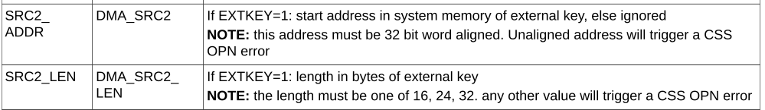

##### 运算返回数据地址写入RES0

// Load pointers for final result (No need to write length (CIPHER command sets CSS_DMA_RES automatically to 1 AES block, 16 bytes)

cssv2_load_dma_res0(cssv2_context, RES_PTR);

W32: A=50190038 W=30000844



#### 配置command

配置CBC mode， 选择external key。

// Write configuration word

cssv2_write_cmd_cfg(cssv2_context, cmd_cfg_word[tv_idx]);

W32: A=50190008 W=00002004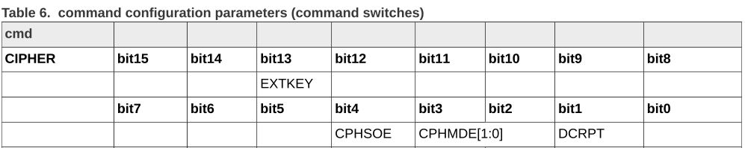

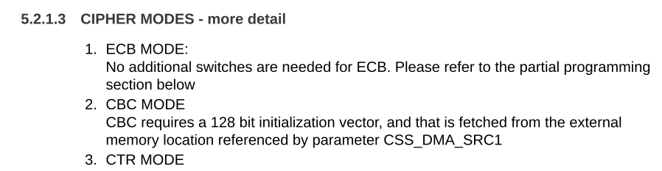

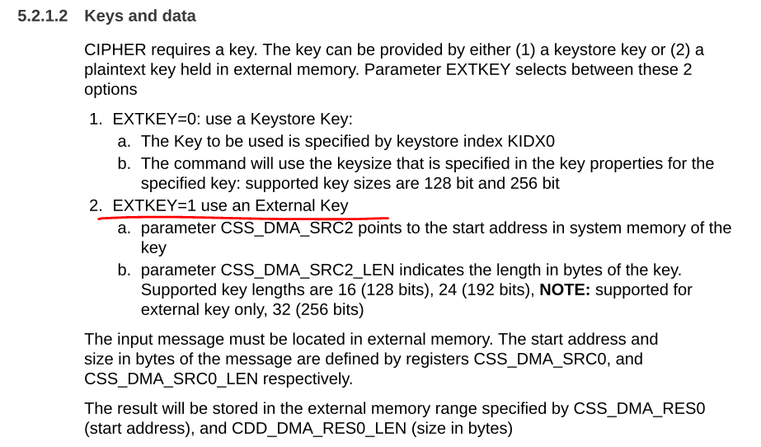

#### start CSS

command ID 设置为0，启动CSS

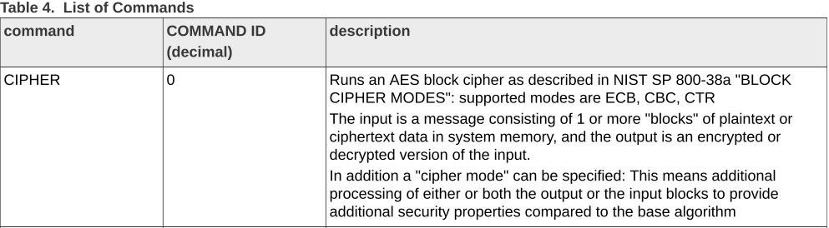

// Start cipher operation

cssv2_start_op(cssv2_context, CSS_CMD_CTRL_CIPHER);

// -------------------------------------------------------------------------

// -- Wait for CSS process completion

cssv2_check_int(cssv2_context);

W32: A=50190004 W=00000003

#### 检验DMA 返回的加解密数据

// -------------------------------------------------------------------------

// -- Check results

// -------------------------------------------------------------------------

// Ciphertext

for (mem_idx = 0; mem_idx < (RES_SIZE / 4); mem_idx++) {

R32(REG32(RES_PTR + (mem_idx << 2)), rdata);

if (rdata != ciphertext[tv_idx][mem_idx]) {

SHOW32(STIMNAME," MISMATCH: Data[%d] Mismatch!!!", mem_idx);

SHOW32(STIMNAME," Exp: 0x%08x", ciphertext[tv_idx][mem_idx]);

SHOW32(STIMNAME," Act: 0x%08x", rdata);

ERROR(STIMNAME, "Fail : Ciphertext is incorrect value");

}

else {

SHOW32(STIMNAME," MATCH: Data[%d] Match!!!", mem_idx);

SHOW32(STIMNAME," Exp: 0x%08x", ciphertext[tv_idx][mem_idx]);

SHOW32(STIMNAME," Act: 0x%08x", rdata);

INFO(STIMNAME, "Pass : Ciphertext is correct value");

}

}

//

}

## Case Porting

CORE_S3_RESOURCES

根据这个宏判定MU是soc端的还是S200端的。

用到的mem map定义

/home/imx95_verif/usr/nxa28190/imx943_1p45/testbench/common_blocks/v_ss_imx943_cssi_vip/tool_data/sray/mem_map

# EWM

## Issue

[TKT0663359](javascript:emxFormLinkClick(%22../common/emxTree.jsp?relId=null&emxSuiteDirectory=components&mode=View&jsTreeID=undefined&otherTollbarParams=relId%2CemxSuiteDirectory%2Cmode%2CjsTreeID&objectId=11392.59601.54220.56479&relId=null%22,%20%22popup%22,%20%22%22,%20%22%22,%20%22%22,%20%22TKT0663359%22,%20%22%22,%20%22%22))  [RT2660]EWM LPO clock was tie 0

**D_IP_EWM_SYN_1.19**

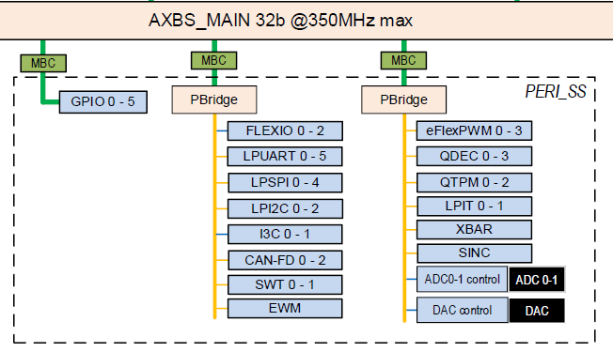

## PIN_MUX

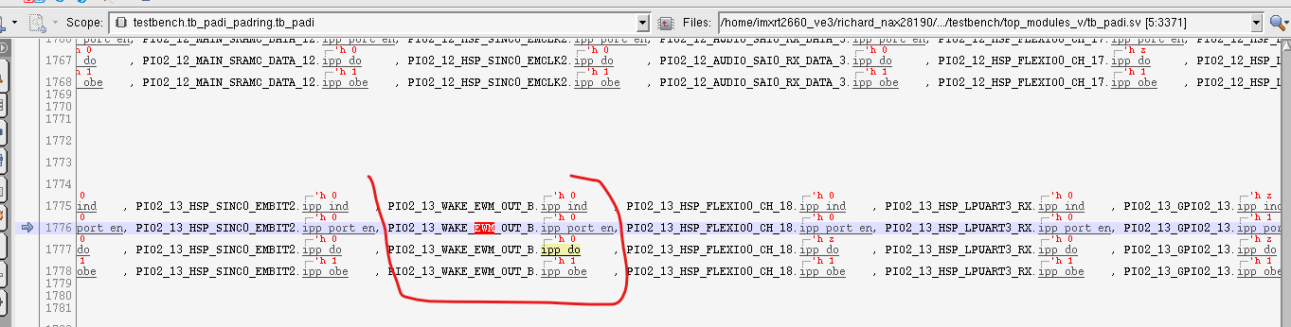

Ipp_port_en =1, IPP_IND 表示EWM 向GPIO输入信号

EWM 只有输出信号。  
如果ipp_port_en=1/ipp_obe=1. Ipp_do表示GPIO向peripheral输出信号

### VIP

##### Interface ewm_out/ewm_in

testbench/common_blocks/v_ip_tbpadi/testbench/modules_v/4_wire/tb_padi_if.sv

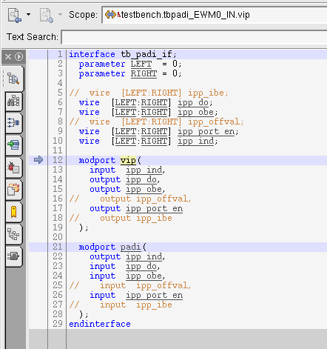

##### 例化



### MUX PTA3_EWM0_IN

tbpadi_EWM0_IN 的信号链接到PTA3_EWM0_IN

将VIP中的ipp_ind连接上

PTA3_EWM0_IN.ipp_port_en

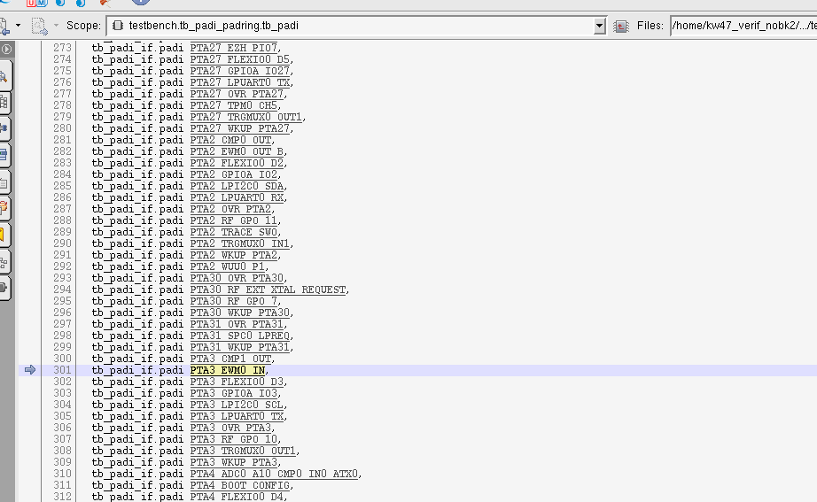

#### C的配置

#### V的配置



### tb_padi_padring

##### 定义

V_SS_KW47_SOC_TB_1.37/testbench/blocks/soc_tb/testbench/top_modules_v/tb_padi_padring.sv

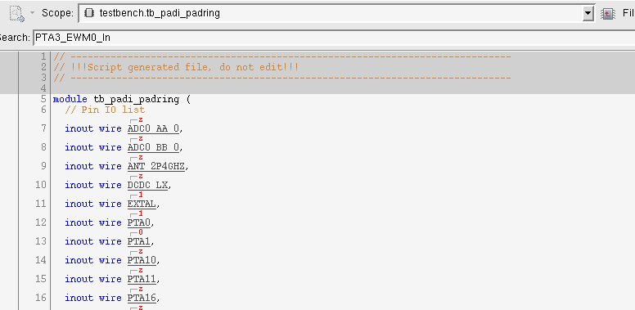



##### 例化

V_SS_KW47_SOC_TB_1.37/testbench/blocks/soc_tb/testbench/top_instances_v/tb_padi_padring_inst.sv

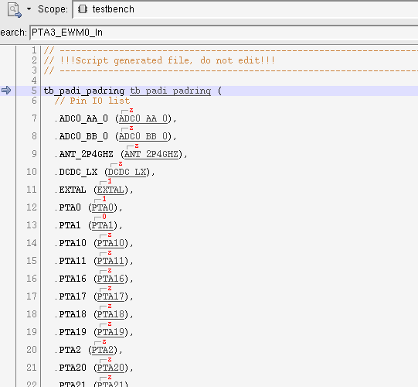

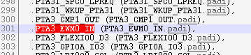

#### Tb_padring

将PTA3 口连接到interface PTA3_pad_if.pad上

1. 从外面传输数据给PAD， VIP端口需要enable obe&port_en. PAD接受do信号。
2. PAD传送数据给外面：ind接收PAD数据

##### 定义

V_SS_KW47_SOC_TB_1.37/testbench/blocks/soc_tb/testbench/top_modules_v/tb_padring.sv

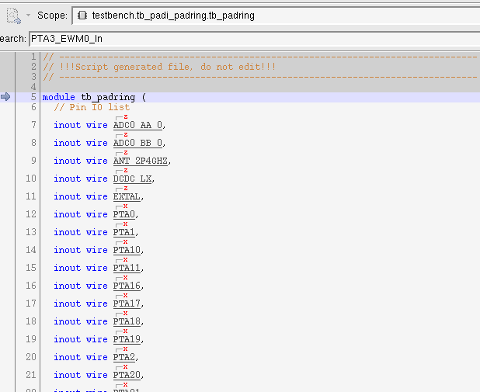

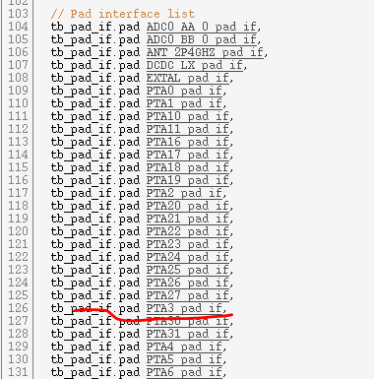

##### 例化

V_SS_KW47_SOC_TB_1.37/testbench/blocks/soc_tb/testbench/top_modules_v/tb_padi_padring.sv

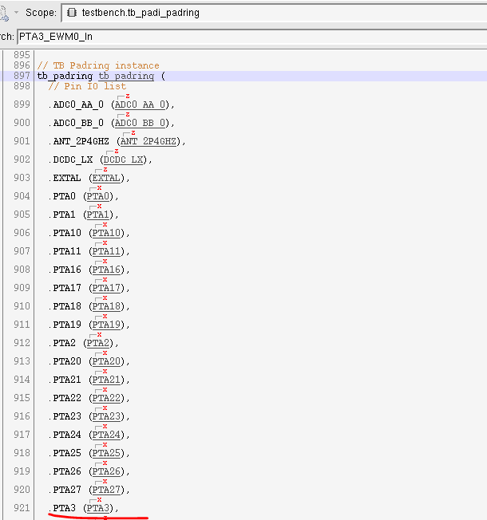

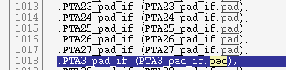

##### 链接

###### 定义

芯片PAD 接到 PTA3_pad_if

如果从外面传输数据给PAD， VIP端口需要enable obe&port_en. PAD接受do信号。

PAD传送数据给外面：ind接收PAD数据

V_SS_KW47_SOC_TB_1.37/testbench/common_blocks/v_ip_tbpadi/testbench/modules_v/4_wire/tb_pad.sv

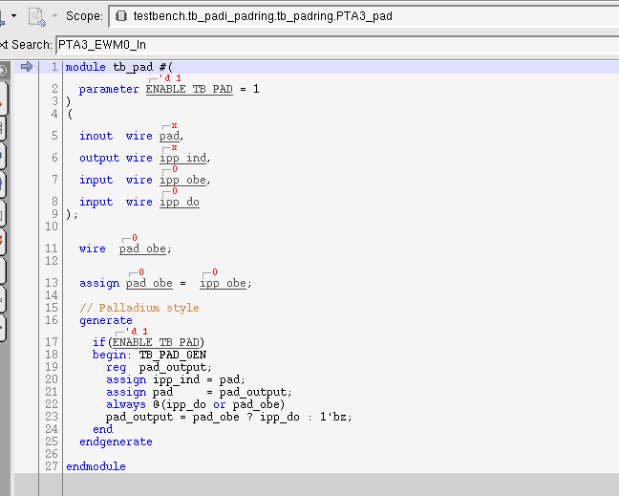

###### 例化

V_SS_KW47_SOC_TB_1.37/testbench/blocks/soc_tb/testbench/top_modules_v/tb_padring.sv

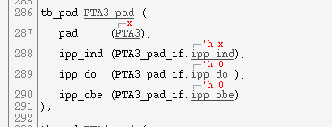

#### Tb_padi

PTA3_pad_if.padi 连接到PTA3_EWM0_IN.padi上

##### 定义

V_SS_KW47_SOC_TB_1.37/testbench/blocks/soc_tb/testbench/top_modules_v/tb_padi.sv

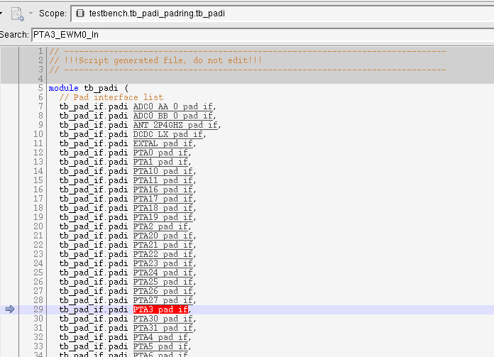



##### 例化

： V_SS_KW47_SOC_TB_1.37/testbench/blocks/soc_tb/testbench/top_modules_v/tb_padi_padring.sv

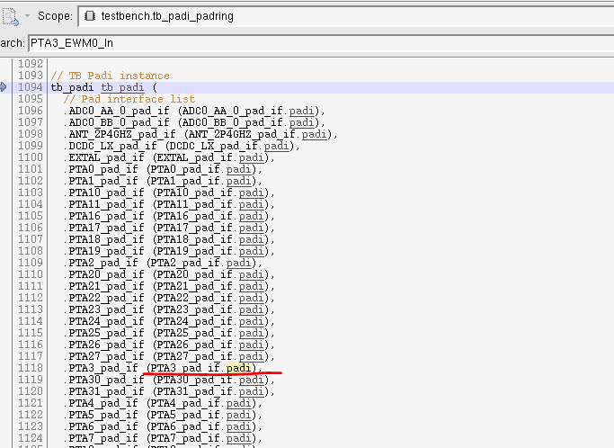

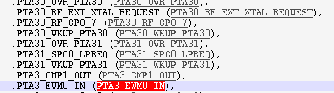

##### 链接

跟据port_en信号，选中PAD的ALT 模式。

如果有多个enable信号，选中最大的那个

这里定义了PAD到VIP的信号传输Tb_pad_if.padi 到 tb_padi_if.padi 的传输

###### 定义

V_SS_KW47_SOC_TB_1.37/testbench/common_blocks/v_ip_tbpadi/testbench/modules_v/4_wire/tb_muxpadi.sv

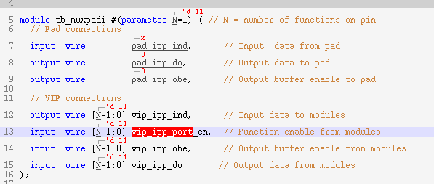

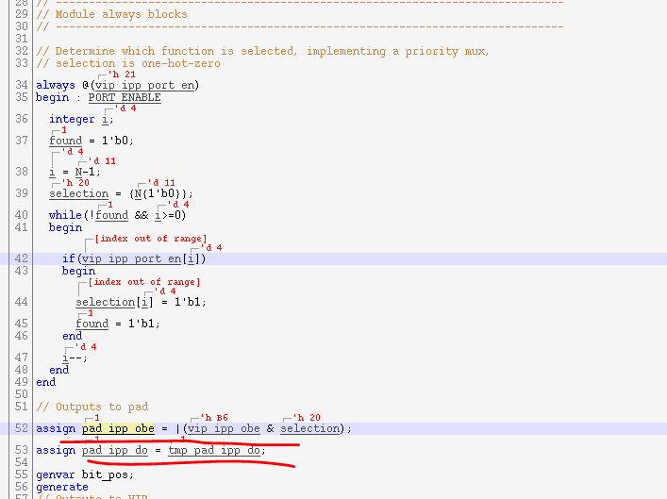

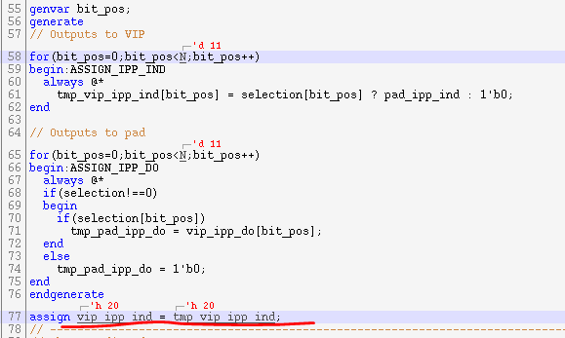

###### 例化

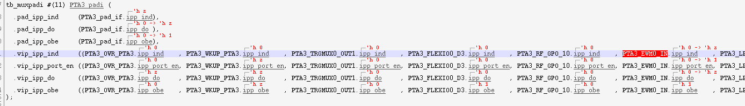

### Tb_padi_mux3

PTA3_EWM0_IN.vip 接到tbpadi_EWM0_IN.padi（VIP interface）

EWM0_IN支持三个引脚。 PTA3/PTA17/PTA20

通过MUX选择对应的引脚PTA3_EWM0_IN.vip/PTA17_EWM0_IN/PTA20_EWM0_IN

#### 定义

V_SS_KW47_SOC_TB_1.37/testbench/common_blocks/v_ip_tbpadi/testbench/modules_v/4_wire/ tb_padi_mux.sv

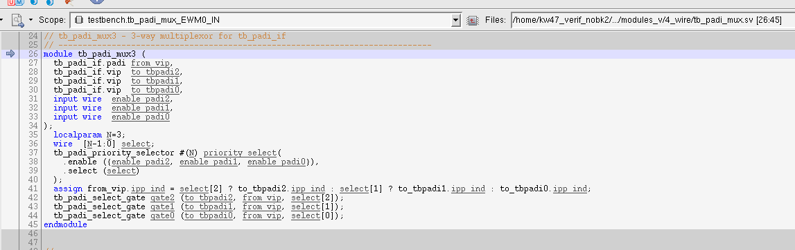

##### 根据priority进行select

C进行soc_allocate_ip后，相关的PIN寄存器会被选中配置。

SV根据RTL中的选中pin，进行Port enable

该FUNCTION 根据port enable信号，进行相关PADI MUX的选择。

优先级从大到小，比如同时开两个enable，这里只会选择最大的那个PADI2>PADI1>PADI0

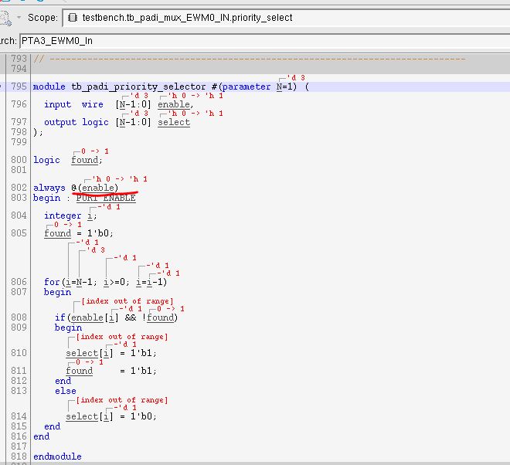

###### Assign Ipp_ind



Mux上的输入，接到VIP的输入

ASSIGN tbpadi_EWM0_IN.padi.ipp_ind = PTA3_EWM0_IN.vip.ind

###### Assign ipp_do

根据select assign ipp_do。VIP 口的输出接到mux上的输入

ASSIGN tbpadi_EWM0_IN.padi.ipp_do = PTA3_EWM0_IN.vip.ipp_do

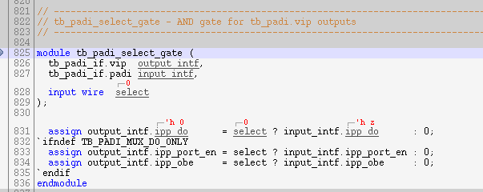

#### 例化

V_SS_KW47_SOC_TB_1.37/testbench/blocks/soc_tb/testbench/top_instances_v/tb_padi_muxed_output.sv

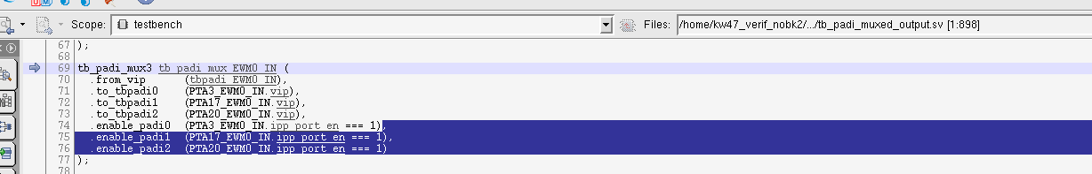

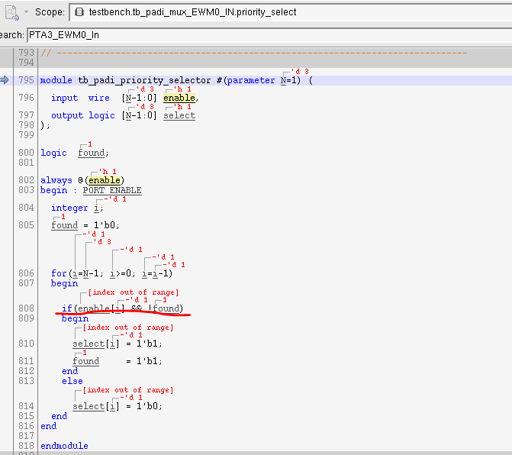

#### 链接

##### V

当C中的配置完成后，SV会根据RTL中的信号选择使能的pin。

PTA3_EWM0_IN.ipp_port_en 置1. Tb_padi_mux3会将VIP 的interface 连接到PTA3_EWM0_IN

V_SS_KW47_SOC_TB_1.37/testbench/blocks/soc_tb/testbench/top_wires_v/tb_padi_assigns.sv

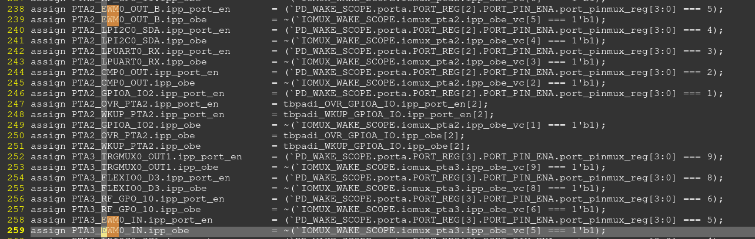

##### C

执行如下代码后

soc_new_request(&ip_request, EWM_IP);

soc_allocate_ip(&ip_request);

会根据arg中的参数进行pinmux的配置。 这里选择了PTA3，进行相关寄存器配置。

CORE_A_C_ARG += EWM_PINMUX_OPT=PIN_OPT0

V_SS_KW47_SOC_TB_1.37/testbench/blocks/soc_tb/tool_data/compiler/include/tb_padi_config_functions.h

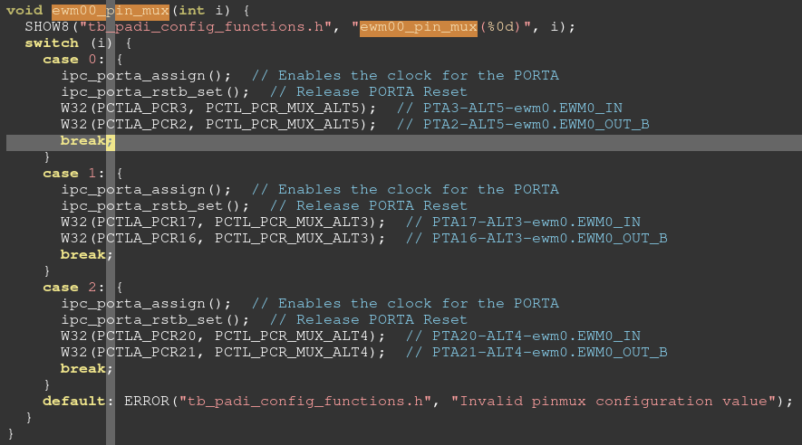

### VIP

传入的interface 为tbpadi_EWM0_IN.vip

#### Ewm_checker模块定义

模块定义ewm_checker:

V_SS_KW47_SOC_TB_1.37/testbench/common_blocks/v_ms_ewm_nxt_vip/testbench/modules_v/ewm_checker.sv

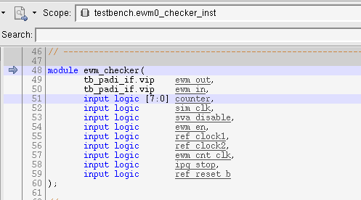

#### 模块例化ewm0_checker_inst

V_SS_KW47_SOC_TB_1.37/testbench/common_blocks/v_ms_ewm_nxt_vip/testbench/instances_v/ ewm_checker_inst.sv

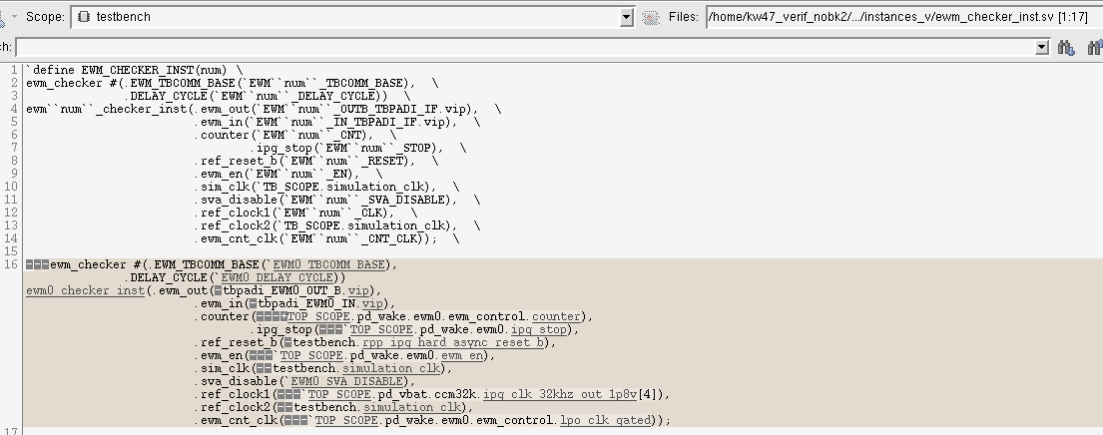

##### 传入的interface tbpadi_EWM0_IN

V_SS_KW47_SOC_TB_1.37/testbench/blocks/soc_tb/testbench/top_wires_v/ tb_padi_muxed_output_if_inst.sv

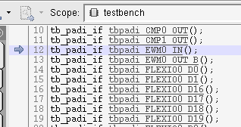

#### 驱动pad

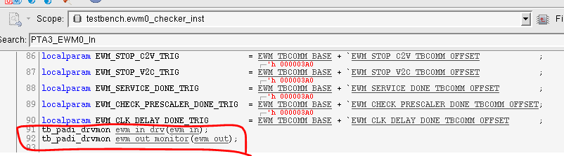

pad驱动tb_padi_drvmon ewm_in_drv

例化两个驱动monitor，传入的参数为interface

用来控制pad的传输

V_SS_KW47_SOC_TB_1.37/testbench/common_blocks/v_cs_pin_clk_drvmon/testbench/modules_v/4_wire/ tb_padi_drvmon.sv

##### ewm_in_drv

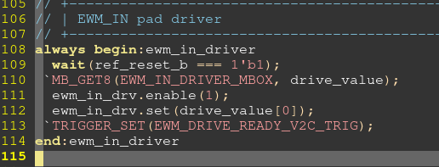

###### 定义

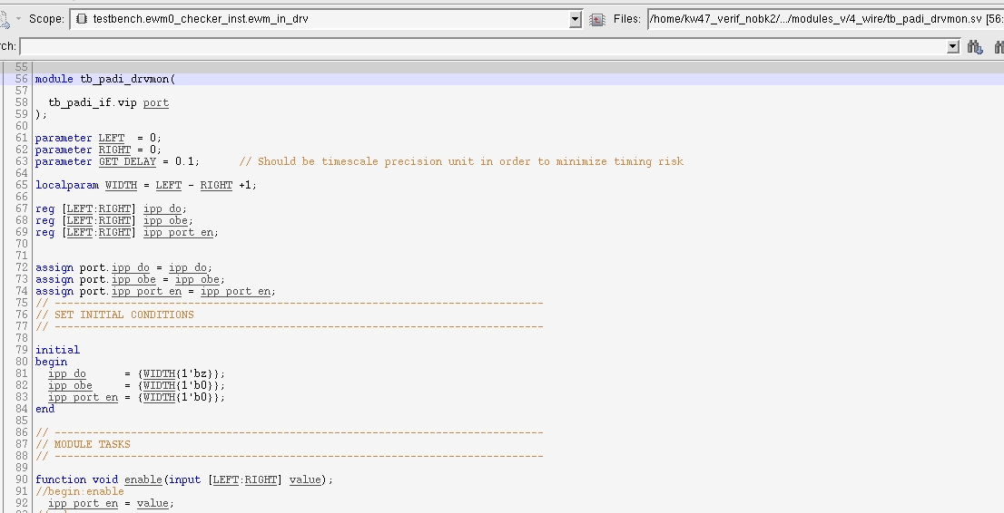

###### Enable

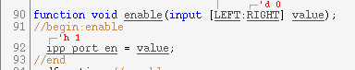

###### Set

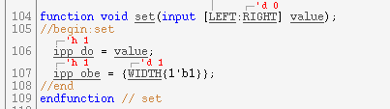

##### ewm_out_monitor

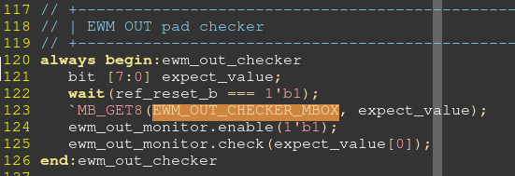

###### 定义

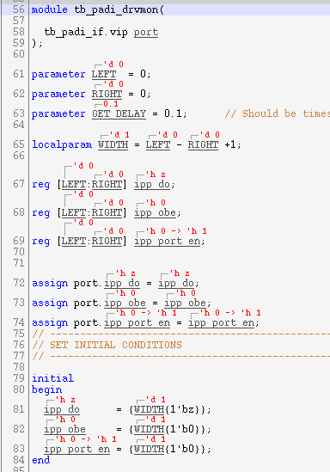

###### Enable

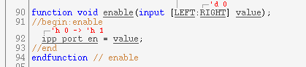

###### Get

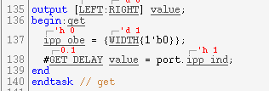

###### Check

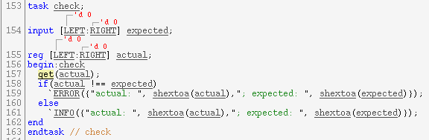

### Tb_pad_if

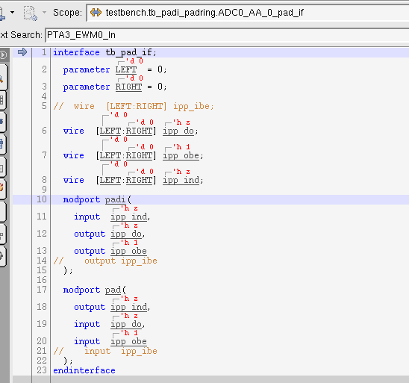

### Tb_padi_if

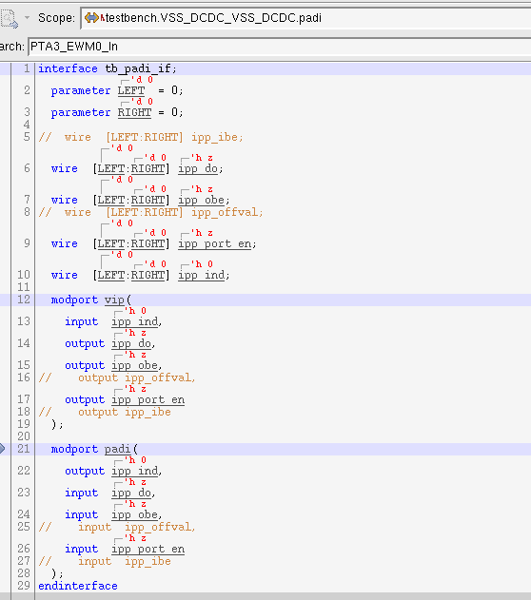

## Register

### CTRL

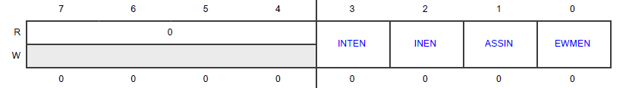

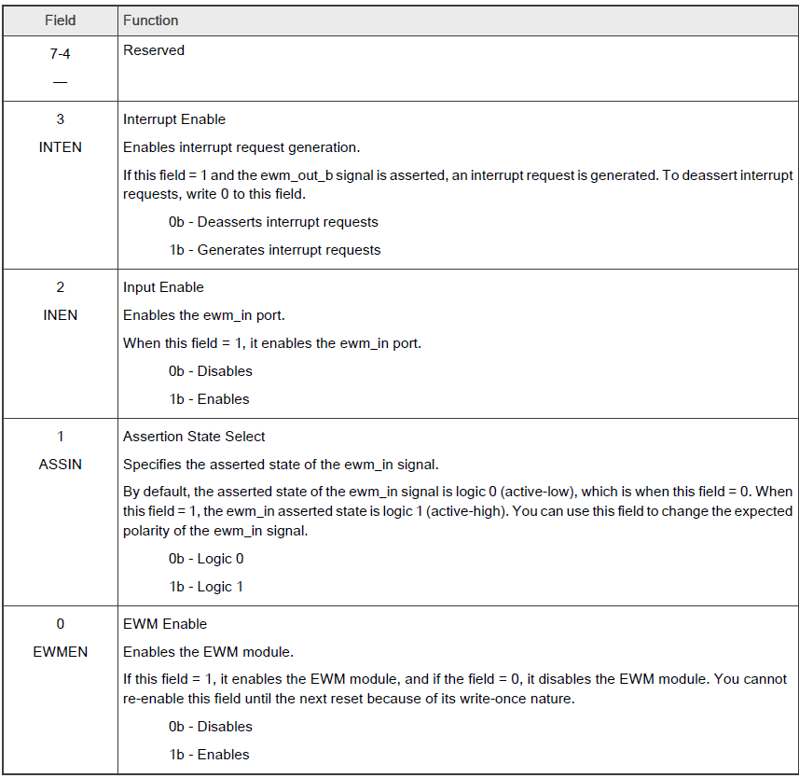

### COMPARE LOW

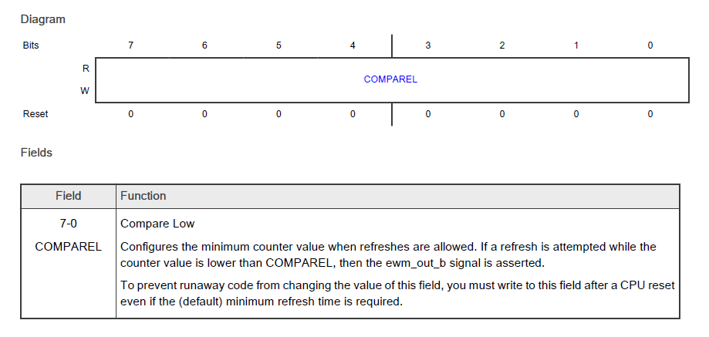

### COMPARE HIGH

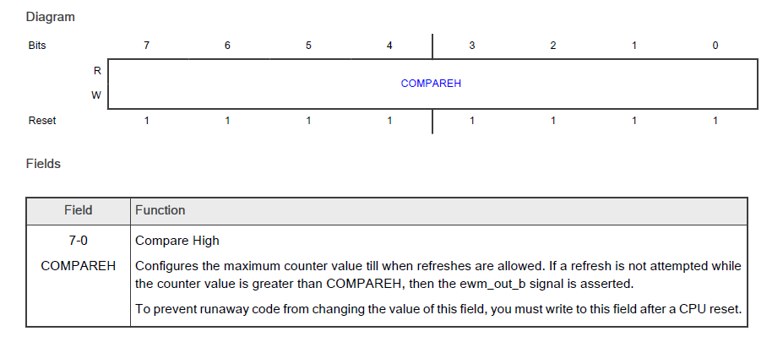

#### CLKPRESCALER

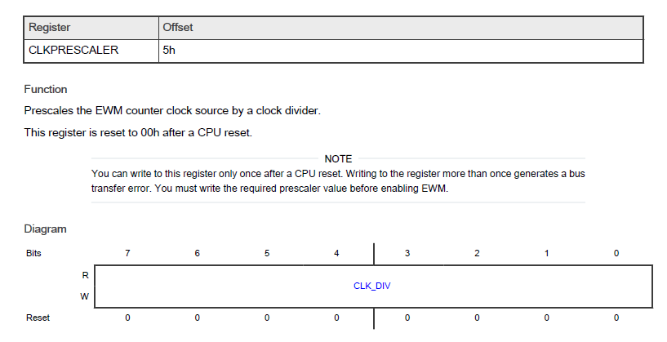

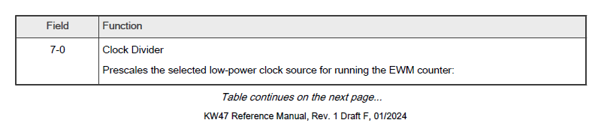

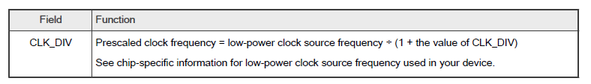

### CLKPRESCALER

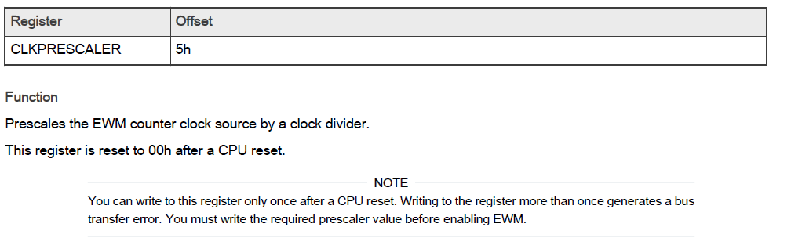

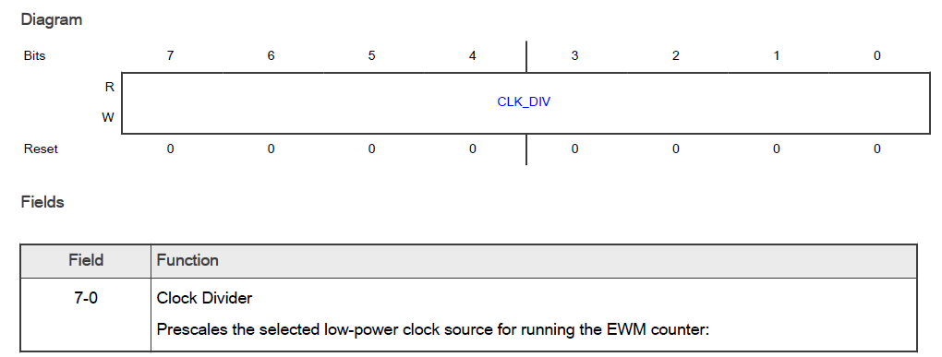

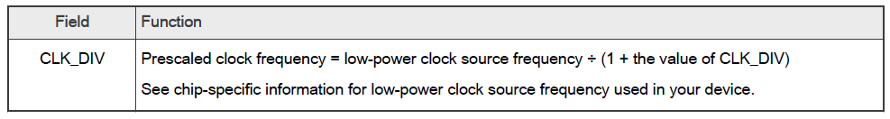

## Function

### Ewm_out_b

默认为1，0表示assert。

如果设置了CMPH/CMPL，EWM enable后

* ASSIN = 0（默认）
  + 等待counter自动计数（LPO clock），counter >CMPH（overflow），不管EWM_in， ewm_out自动assert
  + 如果counter<CMPL的时候refresh EWM，EWM_OUT 自动assert
  + 如果CMPL<counter <CMPH的时候refresh EWM， EWM_OUT是否assert需要看EWM_IN.

如果ASSIN=0时，设置EWM_IN =0(表示assert)，EWM_OUT会assert。设置EWM_IN=1(不assert)，EWM_OUT不会assert。 Refresh后如果EWM_OUT 没有assert，counter会重新计数

* ASSIN =1(EWM_IN=1 时表示assert状态)
  + Overflow， counter<CMPL的情况与如上一致。
  + 只有CMPL<counter<CMPH时，EWM_IN=1, EWM_OUT会assert。EWM_IN=0时，EWM_OUT不会assert。Refresh后，如果没有assert，counter重新计数

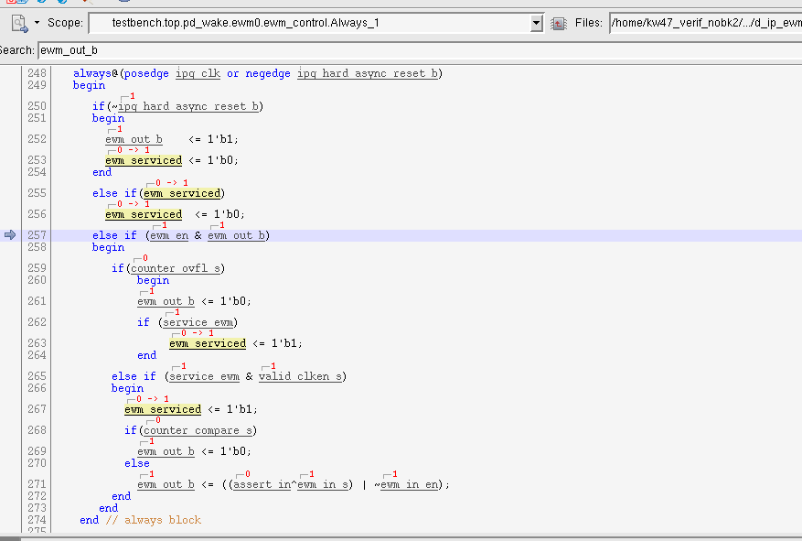

## 2660 ewm vip

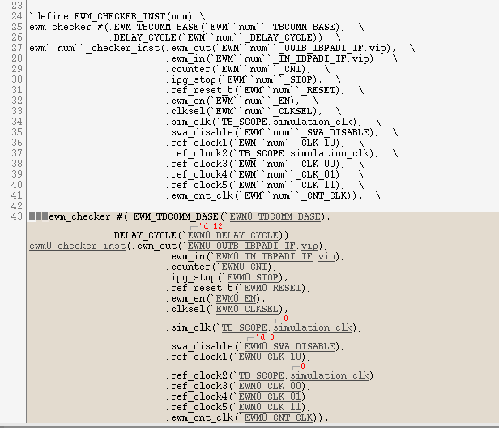

## API

### ewm_configure

第一个参数配置ctrl寄存器

第二个参数配置CMPL 寄存器

第三个参数配置CMPH寄存器

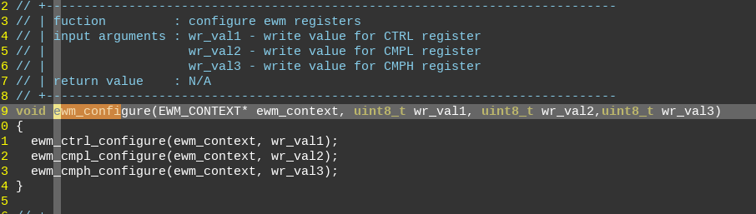

### Ewm_check_counter

使用GPO[2] clock计数，注意C中要配置选择GPO2为计数时钟

第一个参数：counter_range

0: SV检测是此时EWM counter值是否小于CMPL  
1: SV检测EWM counter是否位于CMPL -CMPH之间  
2. 检测EWM counter是否大于CMPH  
3.检测EWM counter值是否为0

第二个参数：clk_cycle

表示在SV进行第一个参数的操作前，delay 几个（计数counter用的）clock

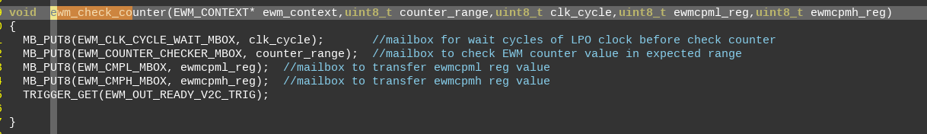

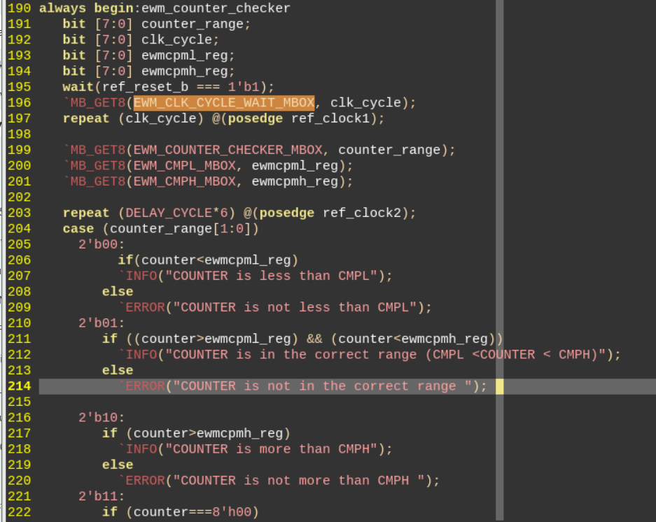

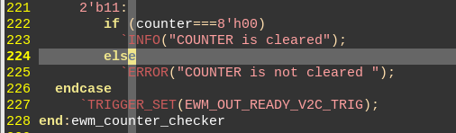

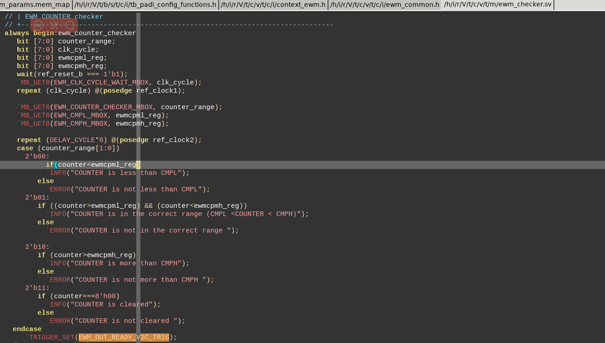

### Ewm_check_output

C:

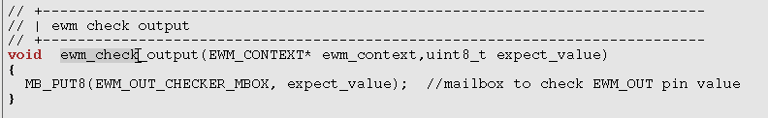

SV:

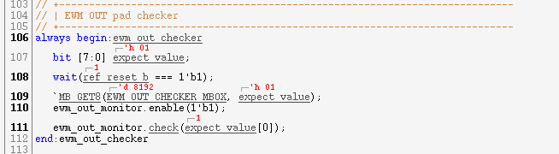

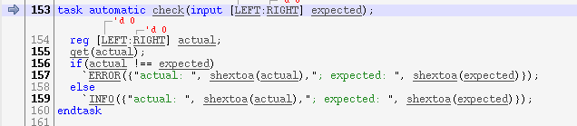

# SWT0

D_IP_SWT_SYN_1.10

Refer： S32K5

## Contact

印度服务器awsc1.  
/home/r43_verif/users/michael

IP design: Nancy Amedeo (nxa09423)

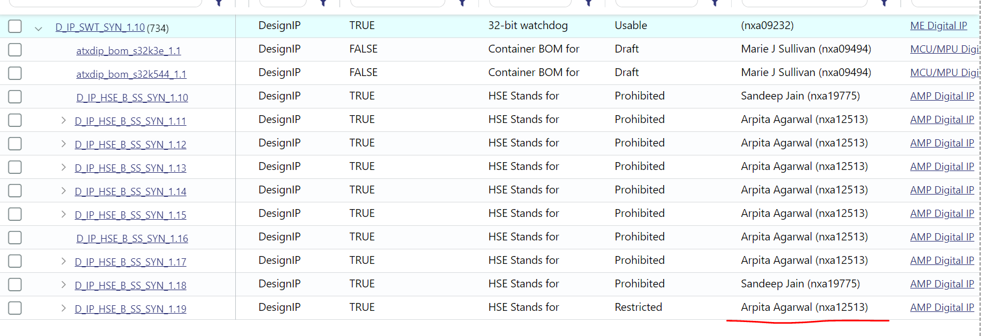

VIP： V_MS_SWT_STIM

Abhinav Gaur (nxa11562) / Tarun Gupta (nxf91281)

## RTL

### RESET VALUE

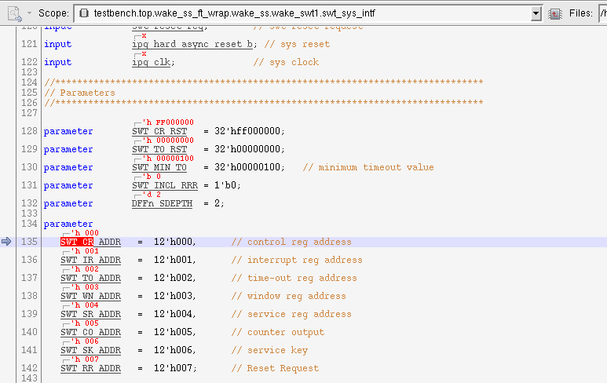

### SWT_CR

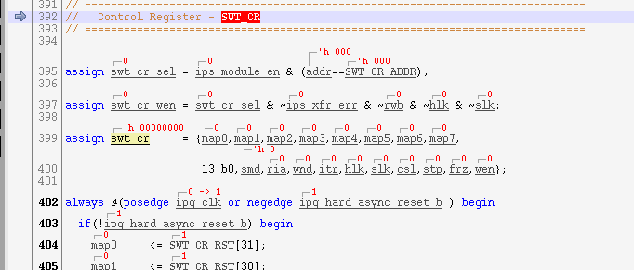

# Low power

## CMC 状态寄存器

testbench.top.syscon_ss_ft_wrap.syscon_ss.syscon_powercon.rt2660_powercon.CMC_INST[0].cmc_controller.cmc_trans_state[4:0]

进入sleep/deepsleep/power down/deep power down CMC 的状态都是10

1F 是开始进入唤醒程序

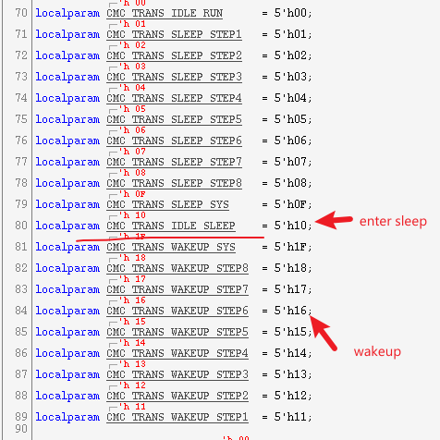

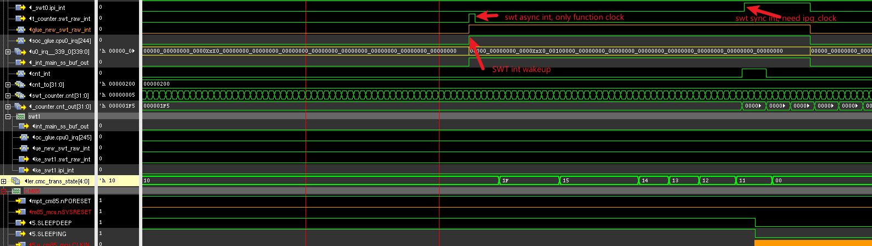

# TRDC

1180 为例：

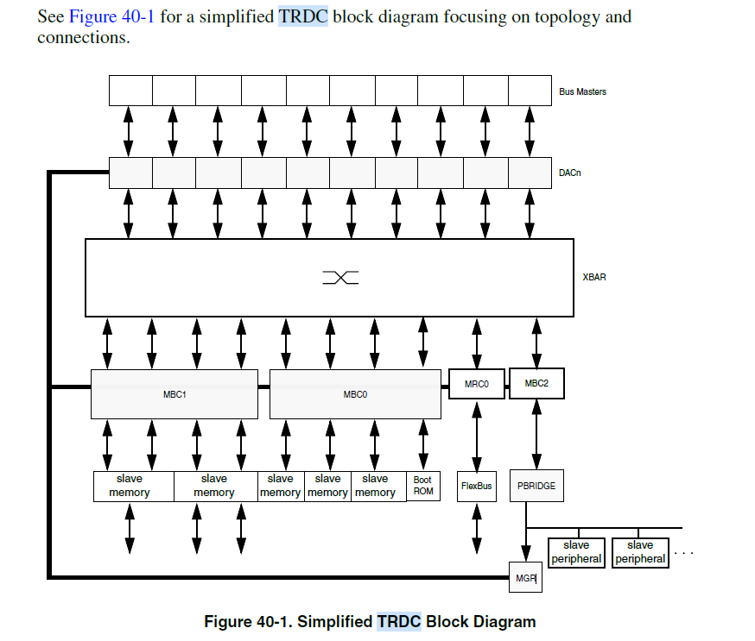

## MGR

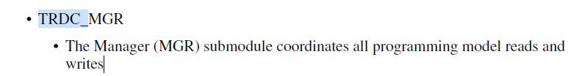

## DAC

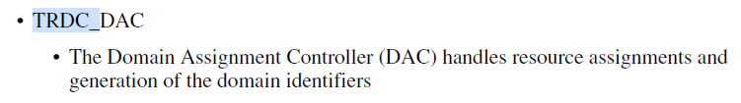

DAC 用于给bus master生成domain identifier。

对用的配置寄存器为：

## MBC



## MRC

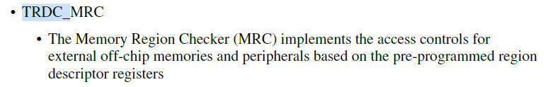

## Register

### DAC master domain assignment

Bit31用于enable DAC

Bit15-14 ： secure、privilege配置

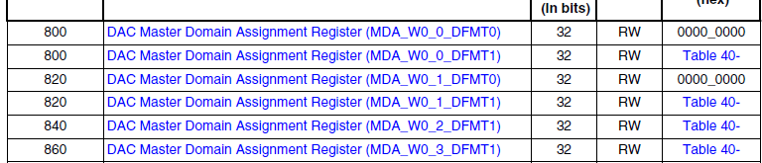

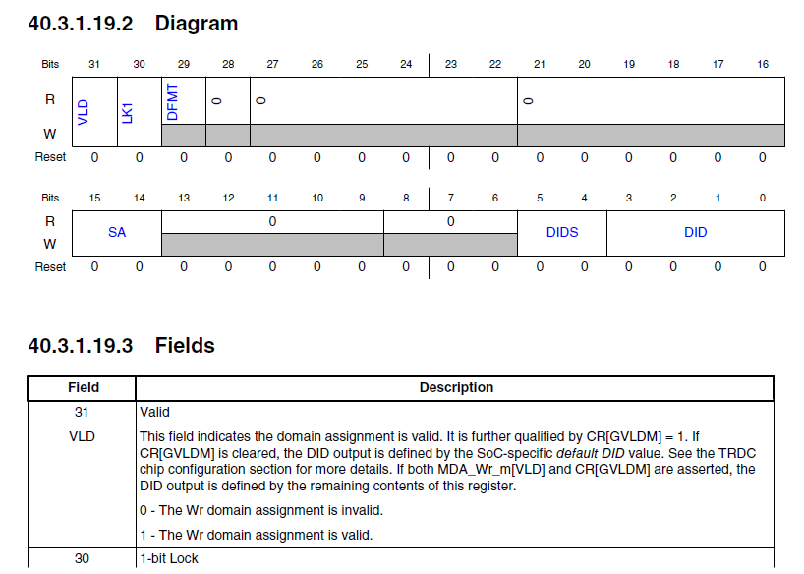

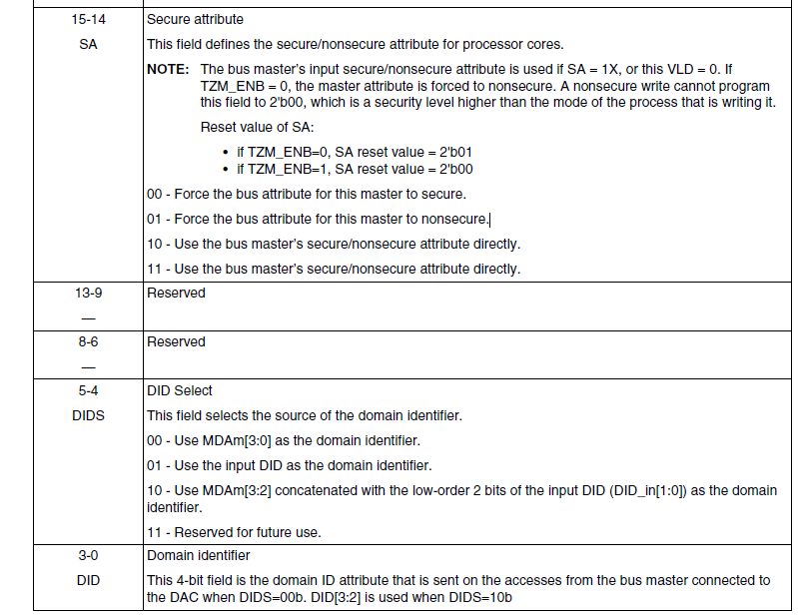

# S110

## Preload

/home/imxrt2660_ve3/richard_nax28190/V_SS_RT2660_SOC_TB_1.15/testbench/blocks/soc_tb/testbench/instances_v/s110_rom_init.sv

### RT2660_MEM_LOADER

Top_tasks_v/tb_mem_loader.sv

1. 初始化CSSI ROM,IMEM,DMEM, IMEM/DMEM的初始化是向sa1f中写入数据,
2. load hex到memory中，
3. IMEM/DMEM SA1F中数据swap到mem中。

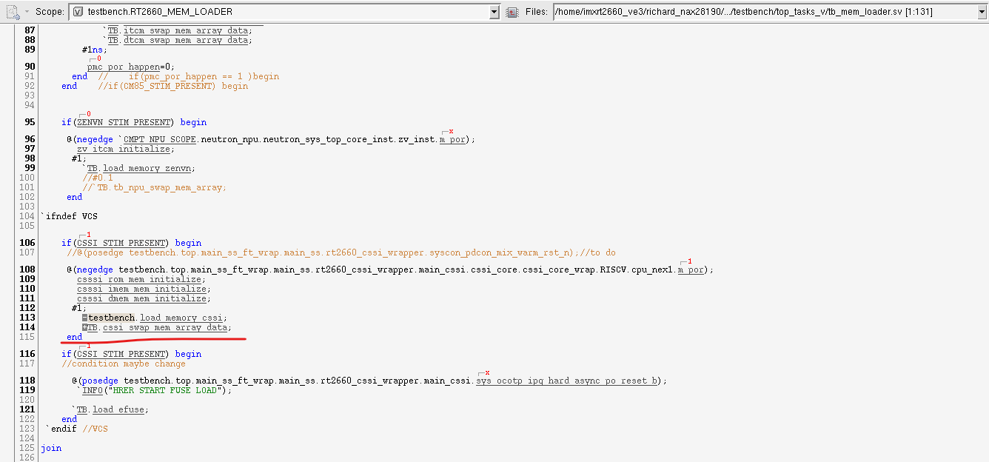

### Mem_initialize

Task_v/tb_mem_tasks.sv

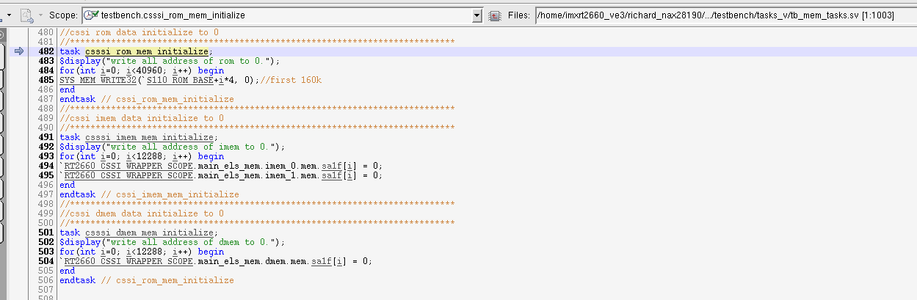

### Load_memory_cssi

Task_v/load_memory_zenv.sv

Load hex文件到CSSI memory中

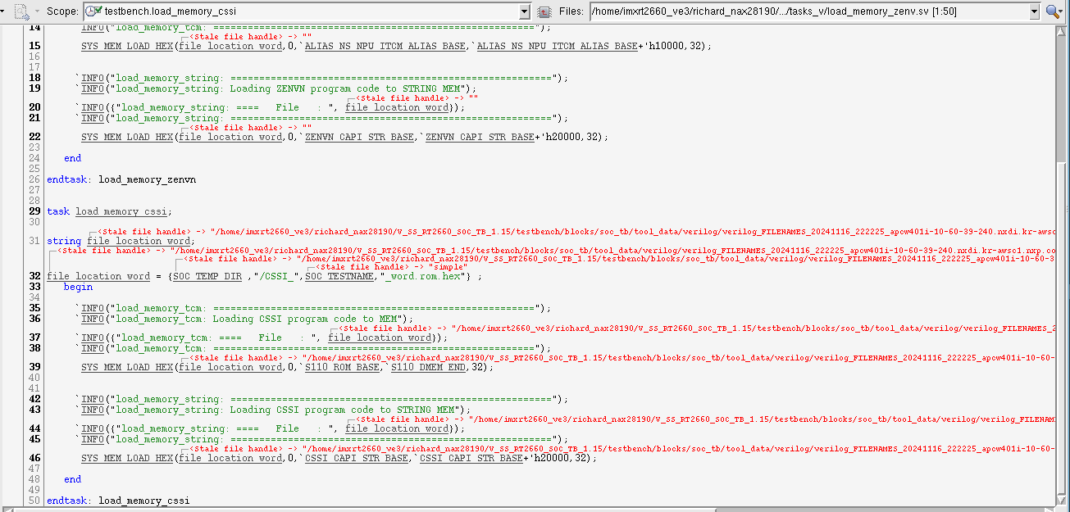

### Cssi_swap_mem_array_data

Tasks_v/cssi_mem_swap.sv

将RAM sa1f中的数据swap到RAM MEM中。Cpu从RAM MEM中获取数据

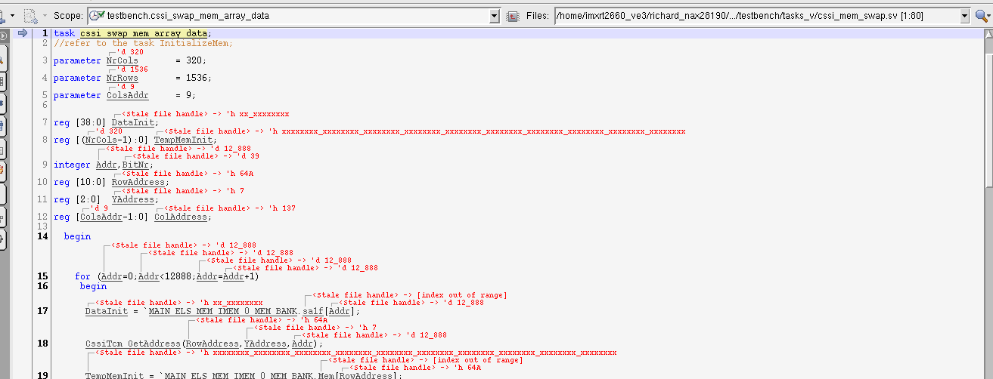

### S110_RAM_INIT

PRELOAD RAM data for testing mapping

testbench/blocks/soc_tb/testbench/instances_v

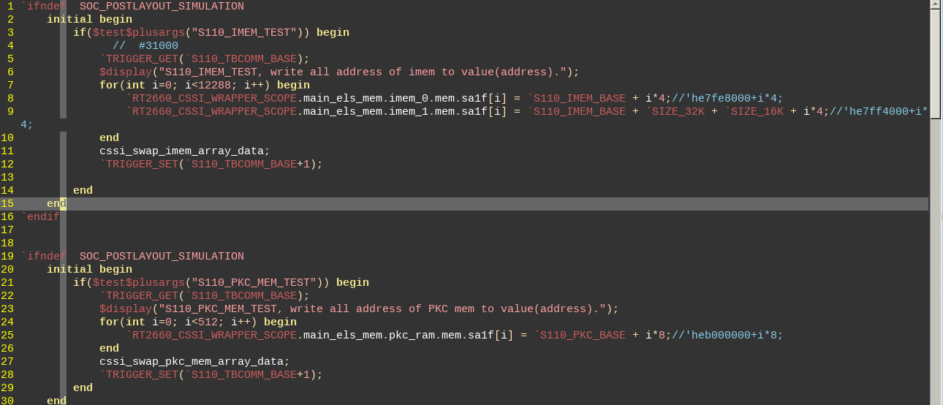

## C架构

### CSSI_RESOURCES/ DCORE_S3_RESOURCES

如下两个宏用来识别属于S110的编译内容

CSSI_RESOURCES/ DCORE_S3_RESOURCES(for legacy VIP code from imx)

testbench/blocks/soc_tb/tool_data/compiler/zenv/cssi/makefile.pre_compile

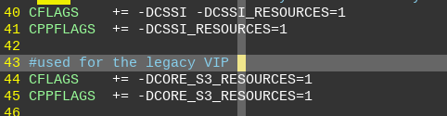

### Environment.h

Test case C 文件中包含environment.h

testbench/blocks/soc_tb/tool_data/compiler/include/environment.h

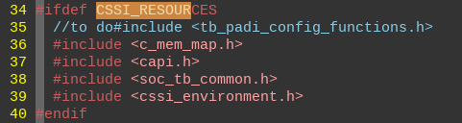

### cssi_environment.h

S110的case会选择cssi_environemnt

testbench/blocks/soc_tb/tool_data/compiler/zenv/cssi/include/cssi_environment.h

#include <context_cssi_api.h> // 支持的IP context

#include <pre_post_main.h>

### context_cssi_api.h

context 架构， 需要跟cssi_ip_request.h配对

当C环境中有S3MU_ID这个宏时， MU VIP 中的context_s3mu.h会被编译

一般定义在arg文件中，如果环境需要这个context默认被编译的时候，可以加到environment.h中。

VIP中的头文件被包含进去

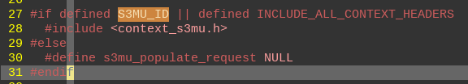

#### Soc_new_request

当调用函数soc_new_request的时候。

会根据ip_type 选择对应的function进行populate函数赋值操作。

Ip_type的定义在s3_ip_request中

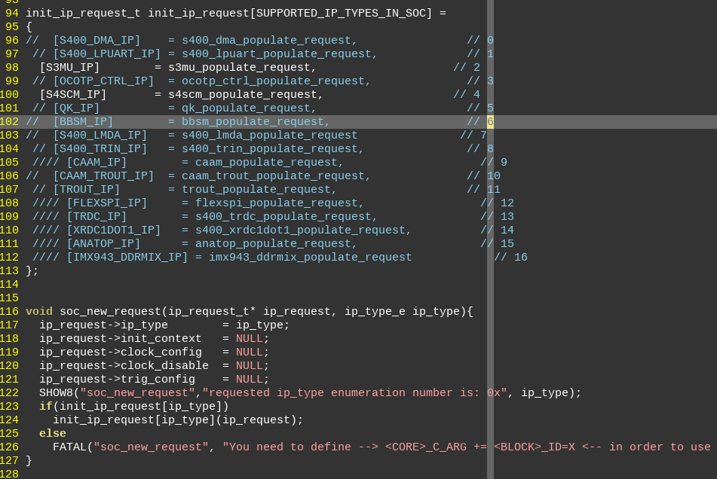

#### 执行populate函数

S3MU VIP中，populate的操作其实也是在进行赋值操作

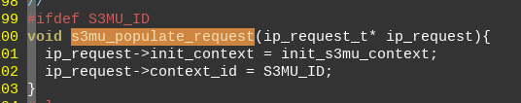

#### Allocate

执行allocate的目的是执行如上new_request获取的函数，

包括create context， clock ， reset， PIN 配置。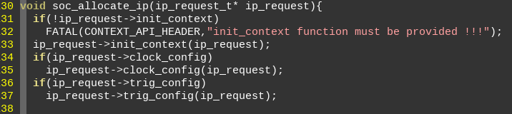

### cssi_ip_request.h

定义了相关module的宏，已经ip_request结构体

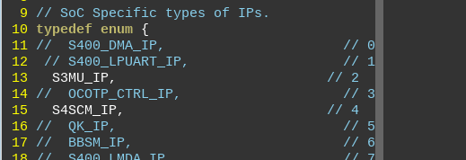

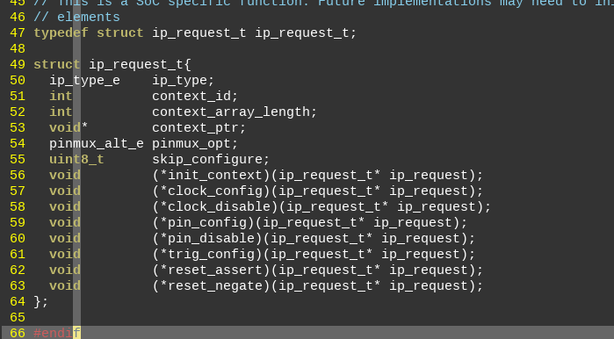

## MU

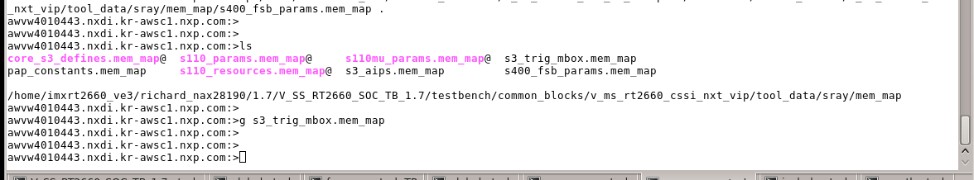

### 定义

Context内宏定义如下

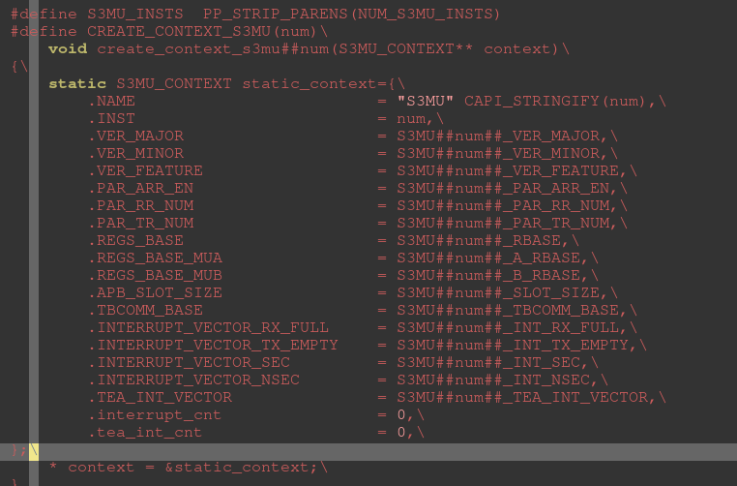

Cssi_vip/s3mu_params.mem_map

S3MU0_RBASE -> `S3MU0_A_RBASE/S3MU0_B_RBASE -> S400_HOST_ADR_S3_MU_APP_RBASE/S400_LOCAL_PERIPHERALS_MUB_RBASE

CSSI_VIP/s400_params.mem_map

S400_HOST_ADR_S3_MU_APP_RBASE (`SENTINEL_BASE_ADDRESS + 32'h00020000)

Soc-mem-map/sys_base_address.mem_map:16:

define SENTINEL_BASE_ADDRESS 'h4750_0000

## mem_map

define all the S110 internal IP base address:

v_ms_rt2660_cssi_nxt_vip/tool_data/sray/mem_map/s110_params.mem_map

### CSSI DMEM

### IMEM

